Anna Chaplaincy in the Diocese of Bath and Wells

The principles and ethos of Anna Chaplaincy
Anna Chaplaincy is named after the widow, Anna, who appears with Simeon in Luke’s gospel; both are good role models of faithful older people. It is an accompanying, person-centred ministry of spiritual care for older people of all faiths, cultures, spiritualities and contexts, and for their families and carers. Anna Chaplaincy also offers advocacy for older people within church and community. Anna Chaplaincy works with people living independently in their own homes, in sheltered housing and retirement complexes and in residential and nursing homes. The ministry is founded in prayer.

Anna Chaplains and Anna Friends may be members of any Christian denomination. They may be lay or ordained, paid or honorary. They must be recognised by their churches as having the necessary qualities and training for Anna Chaplaincy ministry. All Anna Chaplains and Anna Friends have a ministry specification which includes details of their line management and supervision from the local church. They are safely recruited, hold an enhanced DBS and are trained in safeguarding.

Anna Chaplains and Anna Friends become members of the Anna Chaplaincy network, nationally and within the Diocese of Bath and Wells. Anna Chaplains and Anna Friends who serve under the licence held by the Diocese of Bath and Wells are commissioned for five years. This may be renewed by mutual agreement. Anna Chaplains and Anna Friends and their churches will, at all times, serve within the principles, guidelines and ethos of Anna Chaplaincy.

Anna Chaplaincy in your local church and community
If you are interested in establishing Anna Chaplaincy in your local community we suggest that you:
- Pray.
- Discern who might be the Anna Chaplains and Anna Friends. You can start with one person, although a small team is ideal. You could talk with your Christians Together Group and other local parishes.
- Arrange a safer-recruitment process, a DBS and safeguarding training. Basic and Foundations safeguarding training is available at Safeguarding Training Portal (cofeportal.org). You need to register, but that only takes a few moments. A sample application from is available at Appendix A, page 3.
- Arrange for any appropriate Anna Chaplaincy training. There is an Anna Chaplaincy course available please email annachaplaincy@brf.org.uk for details. The Diocese of Bath and Wells also runs a course, Exploring Chaplaincy: www.bathandwells.org.uk/events-and-training/chaplaincy-training/exploring-chaplaincy-3748.php. The Anna Chaplaincy Handbook is available via www.annachaplaincy.org.uk/anna-chaplaincy-handbook. There are also many other resources available at www.annachaplaincy.org.uk
- Agree a Ministry Specification. This can be simple but helps to clarify expectations on all sides. It will include the areas of Anna Chaplaincy ministry, the time commitment expected, any renumeration or expenses and how the Anna Chaplains and Anna Friends will be managed and supervised. Some helpful preparatory questions and a draft is below in Appendix B, page 4-6.
- Sign a sub-licence agreement with the Diocese of Bath and Wells [a lead licensee with Anna Chaplaincy]. You can also sign a direct licence with Anna Chaplaincy. A draft is below in Appendix C, page 7-8.
- Commission your Anna Chaplains and Anna Friends. A draft liturgy is below in Appendix D, page 9.
- Pray for and support your Anna Chaplaincy ministry.

Thank you
Thank you for your interest in Anna Chaplaincy.

If you have any questions, please contact Wendy Haslam, Anna Chaplaincy Lead.
Email: wendy.haslam@bathwells.anglican.org
Website: www.bathandwells.org.uk/anna-chaplaincy

Website: www.annachaplaincy.org.uk/contact-us

The Anna Chaplaincy Prayer
Faithful God, you have promised in Christ to be with us to the end of time.
Come close to those who have lived long and experienced much.
Help them to continue to be faithful and, within the all-age kingdom of God,
to find ways to go on giving and receiving your grace, day by day.
For your glory and your kingdom.
Amen

Appendix A | SAMPLE Application Form – Anna Chaplain or Anna Friend

Name of applicant:

Anna Chaplain or Anna Friend
Address:

Postcode:
Telephone:
E-mail address:
Parish/Benefice & Deanery

To be completed by Applicant:
PCC Approval of the applicant | Date Approved by each relevant PCC:
Approved training completed | Date:
Training details:

Enhanced DBS obtained | Children □ Vulnerable Adults □  Certificate Number:  Issue Date:
Safeguarding completed [Basic awareness and Foundations] | Date:
Signature of applicant: | Signature: Date:

To be completed by Incumbent:
Safer recruitment | I confirm that safer recruitment (interview and references) has been satisfactorily completed and that I will support and facilitate the Applicant's ministry as LWA:  Name in Print:  Signature: Date:

Please return form to: … with:
- Signed Confidential Declaration Form  - Signed Data Privacy Form | - Copy of Ministry Specification

Appendix B | Key Questions to develop a Ministry Specification
These questions refer to any licensed minister or volunteer within the church and are for use in the drawing up of a ministry specification. You may wish to discover the answers to these questions as 'raw' information before writing the specification.

1 What exactly do you want me to do?
2. What freedom to make decisions will I have?
3. Over what period?
4. How much of my time will it involve?
5. Where will I do it?
6. Who will I answer to and how?
7. What resources will be available to me?
8. What support will I receive and from whom?
9. How will any possible problems between us be handled?
10. Will I be able to talk through with someone how the job is going and when?
11. What will count as success?
12. What particular objectives do you want me to fulfil?
13. What preparations/training will I receive and from whom?
14. What opportunities for further training will there be?
15. Who will I work with?
16. How will I relate to others in the pastoral team?
17. Will there be other opportunities for ministry in the parish, which I might be able to undertake when I have done this?
18. Will I be able to give up the job gracefully at the end of this period, or if I find that it is too much for me?
19. Who will arrange for my replacement?
20. How will people know what I have been appointed to do?
21. Will the church reimburse me for expenses incurred in doing this appointment?

Anna Chaplaincy: Sample Ministry Specification

For: (Name)

In the Parish/Benefice of: (Name)

Incumbent: (Name)

Regularity of Contact: monthly/bi-monthly/quarterly. (please insert appropriate time)

Date of Commendation (Date)

Anna Chaplaincy is named after the widow, Anna, who appears with Simeon in Luke’s gospel; both are good role models of faithful older people. It is an accompanying, person-centred ministry of spiritual care for older people of all faiths, cultures, spiritualities and contexts, and for their families and carers. Anna Chaplaincy also offers advocacy for older people within church and community. Anna Chaplaincy works with people living independently in their own homes, in sheltered housing and retirement complexes and in residential and nursing homes. The ministry is founded in prayer.

Anna Chaplains and Anna Friends are commissioned for five years, after which the ministry can be reviewed to see whether the role is still one relevant to church and your own calling.

Tasks
The focus of all Anna Chaplaincy ministry is offering unconditional spiritual care to older people in the community.
You will be involved in the Anna Chaplaincy ministry of the parish in the following ways:
- Please specify the communities you will work with, the focus of your ministry there and the agreed time commitment

Please add other undertakings that may happen from time to time. For example, things like:
- End of life ministry, including funerals
- Worship, including home communions
- Anna Chaplaincy contributions to the church.

Other responsibilities will include (Please add or delete as appropriate):
- working with Anna Chaplaincy team and the wider ministry team and attending monthly/bi-monthly /quarterly meetings

Vacancy (Only to be included if the parish is in vacancy):
This appointment is for the duration of the vacancy. Upon appointment of a new incumbent the ministry specification will be reviewed and renewed. This should take place within a year of the arrival of the incumbent after which point this specification will come to an end.

Support and Accountability
It is important for you to be supported in your role and to be accountable, because your ministry is exercised on behalf of the Church. The Incumbent (or insert Incumbent's delegate) will be available to consult with about any concerns or issues and to look at draft services. You will be exercising your role alongside other Anna Chaplains and Anna Friends and members of the ministry team and this collegiality offers support and accountability within the team. You are accountable to the Incumbent for the tasks and responsibilities agreed.

The time involved in the role will vary according to your personal circumstances and the local needs. The Incumbent will regularly review with you what is best for you and the local context.

Expenses
An Anna Chaplain or Anna Friend should not be prevented from exercising their calling by concerns about expenses but parish resources need to be managed. The general resources of the parish/benefice will be available to you, e.g. use of the office equipment, photocopier etc. If services will incur expenses then these must be approved beforehand with the Incumbent.

Please insert Parish policy for travel expenses.

Review
You will have an annual review of this specification and your ministry with the Incumbent. Circumstances inevitably change and you are free to step down from the role by giving one month's notice so that alternative arrangements can be made to cover services.

The next review will be (insert date).

I am happy to exercise this voluntary role on the basis of this ministry specification.
Anna Chaplain or Anna Friend signature:

I support (name) in this role and will provide oversight.
Incumbent signature:

I support (name) in this role and will provide ongoing support and guidance.
Incumbent's delegate's signature (if applicable)

Date:

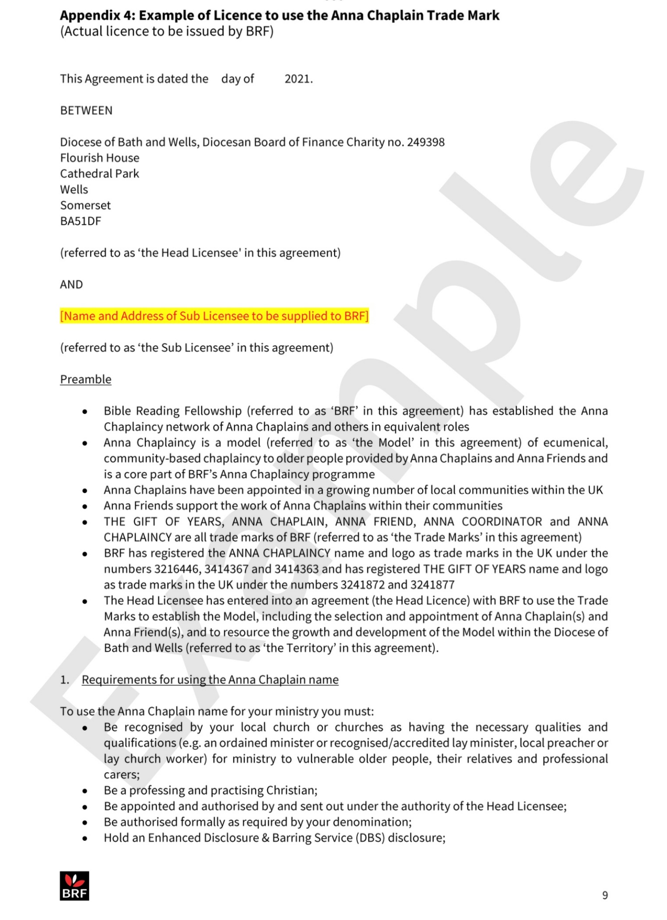
Appendix C | Sample Sub-Licence Agreement
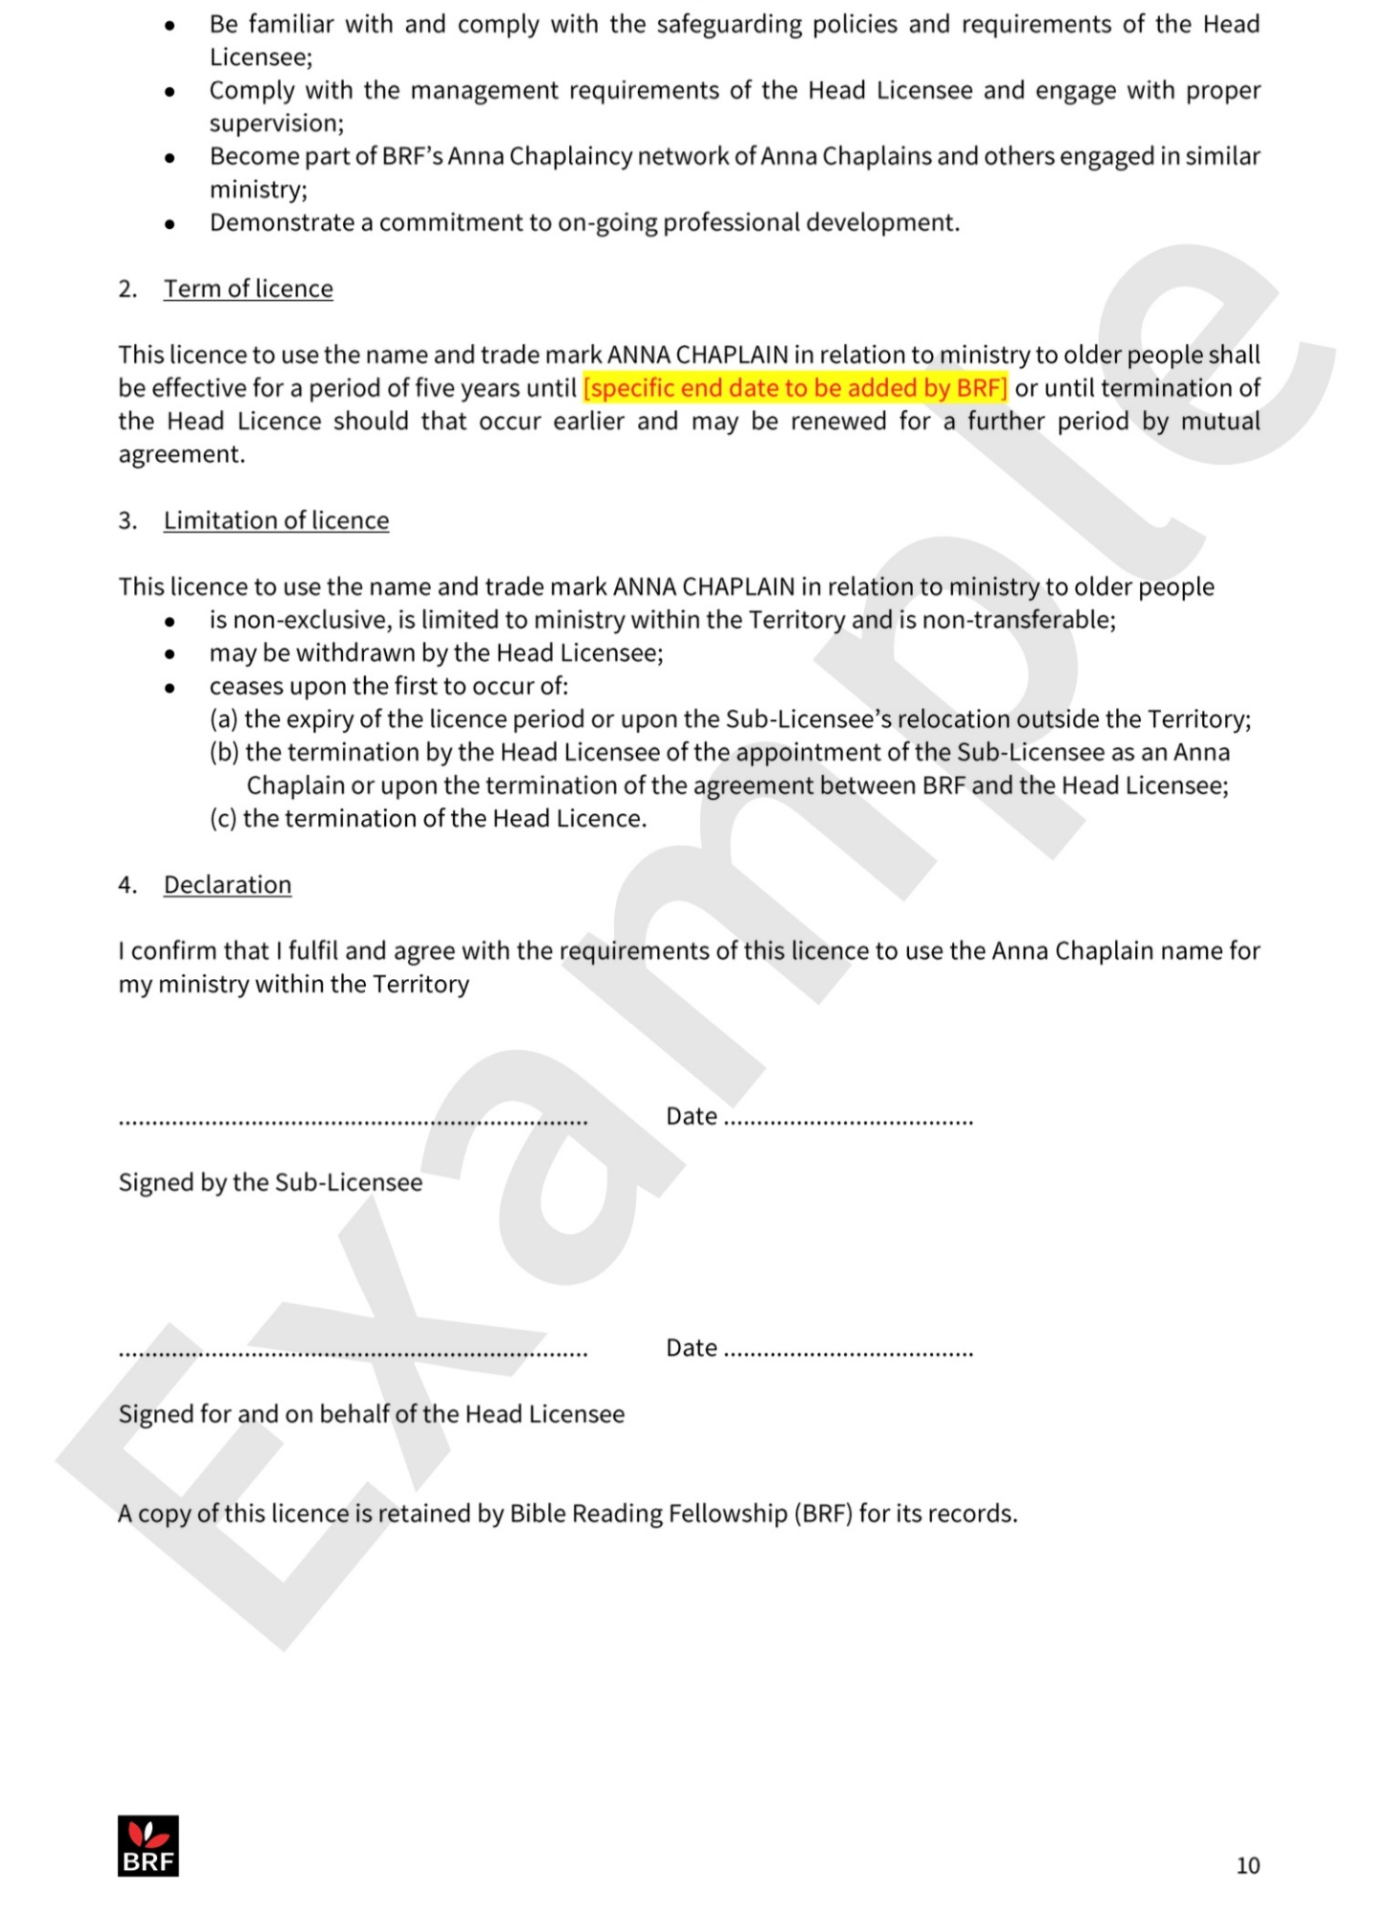

Appendix D | Commissioning liturgy

Opening sentences
“I am about to do a new thing; now it springs forth –
I will make a way in the wilderness and rivers in the desert”
Isaiah 43:19

Underneath winter’s struggle for survival
Life waits to be born.
After long periods of apparent desolation
Shoots appear, and colour warms the earth,
Gladdening the heart with hope.
Buried beneath our fears, preoccupations,
Apparent deadness, Life waits:
The growing is in the waiting”
Ann Lewin, Watching for the Kingfisher (Canterbury Press 2004)

Reading
Luke Chapter 2 - the story of Simeon and Anna

Prayers of commissioning
St Paul, writing to the Christians in Rome says, ‘For as in one body we have many members, and not all the members have the same function, so we, who are many, are one body in Christ, and individually we are members one of another. We have gifts that differ according to the grace given to us: prophecy, in proportion to faith; ministry, in ministering; the teacher, in teaching; the exhorter, in exhortation; the giver, in generosity; the leader, in diligence; the compassionate, in cheerfulness.’ (Romans 12: 4-8)

People of God, Christ invites each of us to faithful discipleship and service. We are all called to different ministries as we seek to live God’s love. As we commission these people/persons today, will you, with them, and as baptised disciples of Christ, renew your commitment to the loving service of God, of one another and of all people?
With the help of God, we will.

(name) has been called to work as an Anna Chaplain / Friend. Will you, as the people of God here in this place, support and pray for her/him in his ministry?
With the help of God, I will.

Minister addresses the one to be commissioned
(name) , you have been chosen to be an Anna Chaplain / Friend. Do you believe that God is calling you to this service?
I do

Will you, as long as you are engaged in this work, seek to perform it prayerfully and in a spirit of mutual respect and collaboration?
With the help of God, I will.

Will you seek to develop the faith, gifts and skills God has given you as you share in Christ’s mission and ministry?
With the help of God, I will

Heavenly Father, send down your Holy Spirit on your servant whom you have called to this ministry. Help him to listen patiently, respond wisely and pray faithfully. Give him courage to speak up for those whose voice may not otherwise be heard.
May her/his hands be ready to do your work.
May her/his eyes be open to recognise those in need.
May her/his ears hear soft-spoken words of pain and sorrow.
May her/his voice speak of healing and peace.
May her/his feet walk the extra mile with those who falter,
and may he always be aware of your presence guiding him and your loving protection around him in all that he does.
Amen.

Blessing
We have experienced God’s mercy
We have been filled by God’s Word
We know the steadfastness of God’s love.
So, now let the words that go out from our mouths
And the deeds that are lived by our hands
Return not empty but accomplish God’s purpose and
Succeed in the things for which God sends us into the world.
Go in the name of Christ.
Amen

