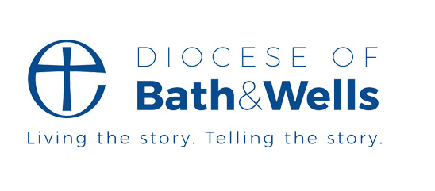
Environment & Nature Family Activities to enjoy together at home

Hello to all families home-schooling and staying in!

During these unusual times, many of us have an opportunity to slow down and enjoy some precious family time. At this time of year, nature is busy and together we can enjoy it, explore and learn from it in ways that we are often just too busy to do or side-tracked by other commitments and chores. If you have a garden or outdoors area, you can explore within the social-distancing guidelines. But don’t worry if you don’t, there’s still plenty we can do.

Each week we will post activities for you to engage with nature together and remind us of how awesome creation is! Here are Week 3’s activities. Please do email us pictures of what you get up to, we love to hear from you.

Have Fun!

The Diocese of Bath & Wells Environment Team
(sara.jeffery@bathwells.anglican.org)

Week 3:

This week we are thinking about food. Now is such a good time to enjoy cooking and preparing food together- life is usually such a rush! But whilst you are creating, take a moment to learn a bit more about what’s on your plate! To start us off, have a think about what the bible tells us about who provides our food. In Genesis 1 God said, "I have given you every plant with seeds on the face of the earth and every tree that has fruit with seeds. This will be your food” (Genesis 1:29, The Message Bible) from The Message Bible. How has God shown His love for us by giving us many kinds of food?

- Activity 1: Where Does it Come From?
With an adult's help, find out where your food comes from. Most packaging will tell you e.g. strawberries from Spain, runner beans from Portugal etc. Identify on a map where these countries are. How many countries have you found?

- Activity 2: How Does it Get to My Plate?
What are the ways our food reaches our plates? Plane? Ship? Truck? Do you walk or drive to the shops to buy it? How do people get their food in other countries?

Here are some pictures for you to think about:

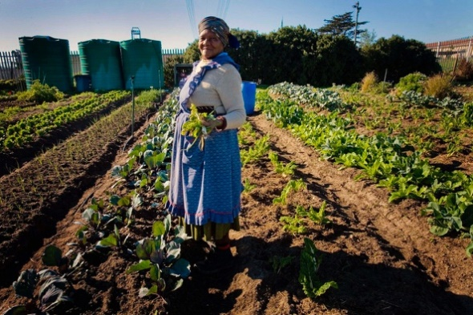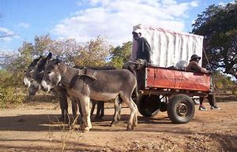

https://media.nature.com/lw685/nature-assets/nature/journal/v474/n7352_supp/images/474S020a-i1.0.jpg
https://gretchenbloemetje.blogspot.com/2013/03/trip-to-zimbabwe-victoria-falls.html

How does the food you eat grow? On a bush? Underground? How does it have to be packaged and stored to reach us in good condition?

The distance food travels to us is called ‘Food Miles’. The further it travels, the bigger the impact that travel has on our environment. Have a look at the Food Miles website to work out how far your favourite foods have come:
www.foodmiles.com

Which food travels the most miles? It’s not always what you think- sometimes food is shipped to several countries in its processing journey.

- Activity 3: Eat Local.
In what ways is eating food grown and produced locally better for the environment?
www.youtube.com/watch?v=9Opt06QF9WY

If we only ate food grown in our country, what could we eat? What would we miss?
What is Seasonal Food? What foods can you find that are only sold at certain times of year?

Try planning and making (if you can find all you need now- if not wait a few weeks and just plan what you will do when you can access everything) a meal made from only local food and food that is in season. Try the link below for some tips: www.eatseasonably.co.uk

