60 steps

towards

being green

Introduction
Our environment is under threat from pollution and global warming. Unstable weather patterns producing floods, extreme storms and heat waves with resultant fires are on the increase.
Greenhouse gasses, such as carbon dioxide, are the main cause of global warming. Most CO2 comes from the combustion of fossil fuels in cars, buildings, factories, and power plants. Other gases contribute to the problem such as methane released from landfills, natural gas and petroleum industries, and agriculture (especially from grazing animals); nitrous oxide from fertilizers; and gases used for refrigeration and industrial processes. The loss of forests and marshland that would otherwise store carbon exacerbates the problem. Plants and animals are struggling to adapt to this changing environment, and are also hard hit by pollution caused by micro-plastics, waste chemicals from industry and vehicles, and pesticides, herbicides and fungicides used in agriculture. Insects are declining at a rate of 2.5% per year with a third of species facing extinction, bird numbers have plummeted, coral reefs are being damaged—we are at a critical point in the Earth’s history. Humans rely on insects as pollinators, we depend upon plants for oxygen and the transpiration of plants drives the weather systems that produce rain. If we do nothing the world will become impoverished, with rising sea levels reducing land mass, desertification of large areas, and increasing food and water shortages.
The poorest will suffer most. As Christians we believe that we have been given the responsibility of caring for this earth, of protecting the poor and the vulnerable and of working for justice.
Faced with a problem as huge as climate change it is tempting to believe that there is nothing we can do, but our faith teaches us to have a dynamic active hope. If each of us makes some simple changes it will make a difference. So below are a few ways in which we can all help. It is not an exhaustive list, and anyone who wishes to become more involved can join organisations or lobby businesses and government, but we hope that you will find these simple suggestions a useful place to start.
The Reverend Prebendary Mary Bide
Sub-Dean, Wells Cathedral
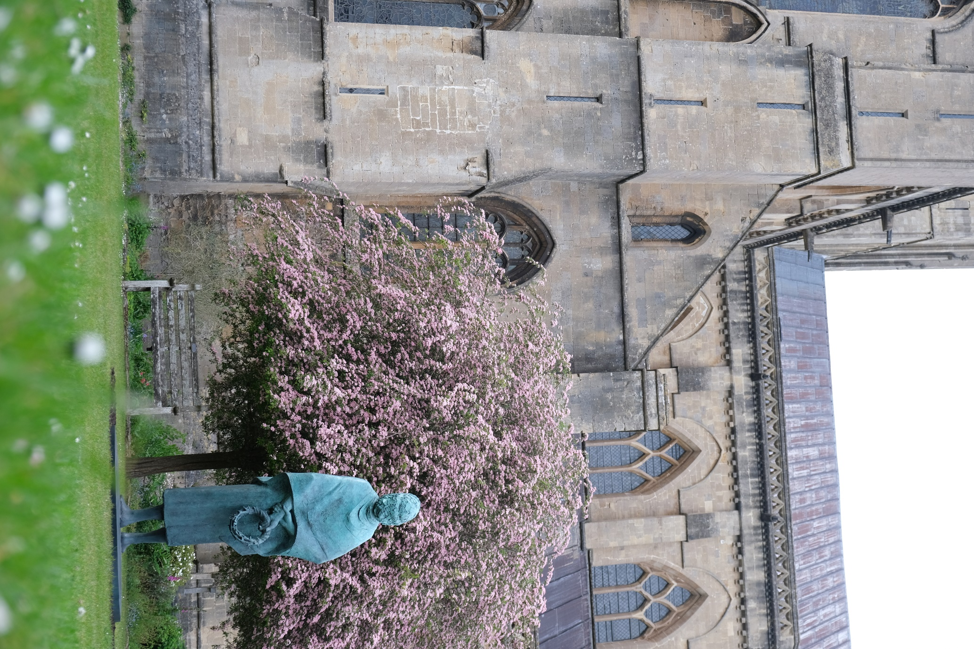

Energy Use in the Home
How much energy do you use? Reducing it will not only save you money, but will reduce the amount of carbon dioxide in the atmosphere. The Energy Saving Trust provides many useful tips.

The suggestions marked ‘*’ make a significant difference.

Top up your roof insulation *

Invest in double glazing

Ensure hot water tank is properly lagged *

Turn down radiators in rooms that are rarely used

Turn off TV, chargers and computers at mains when not in use

Invest in solar panels

Offset your carbon use through Climate Stewards

Turn down your hot water and central heating thermostat by
one degree and put on an extra jumper

Use LED light bulbs and turn off lights when you leave the room
and do not leave external lighting on all night

Purchase your fuel from a green energy supplier such as
Ecotricity or Good Energy

Food
Our choice of food not only affects our health but the health of the planet.

Use reusable shopping bags

Avoid prepacked food

Buy Fair Trade goods where possible

Buy locally produced food where possible

Buy organic food where possible

Eat less red meat *

Avoid foods containing palm oil *

Consider animal welfare when choosing meat, fish and dairy products

Buy fish from sustainable fish stocks (see the Good Fish Guide)

Check whether milk is available in refillable glass bottles near you

Clothing
Most clothes made from man-made fibres end up in land fill. These clothes are also a source of micro-plastics which have contaminated all life forms, even in the Arctic.

Avoid acrylic, nylon and polyester which release micro-plastics
when washed *

Choose natural fabrics or viscose and modal, which are made
from cellulose

Wash clothes in cool water

Use a short gentle wash cycle

Wash clothes less often

Avoid using a tumble drier

Recycle your old clothes

Use ecologically friendly washing liquid

Mend shoes rather than replace

Investigate ethical clothes brands

Garden
The garden can be an oasis of peace, not just for us, but also for birds and insects.

Avoid pesticides and weedkillers *

Avoid peat-based compost *

Use copper bands or Strulch to deter slugs rather than slug pellets

Use nematodes to deal with specific pests

Plant bee and butterfly friendly flowers (see the RHS website)

Allow some areas of lawn to grow a little longer to provide food and shelter for insects

Consider planting an area of meadow

Feed the birds in winter and put up nest boxes, bat boxes or bug hotels

Make a pond (even a tiny pond increases biodiversity)

Make your own compost

Other Household Items

Use environmentally friendly cleaning products and recycled paper products

Avoid wet wipes

Do not waste water (see Waterwise) *

Do not automatically replace your phone when the contract expires

When you replace your duvet or bedding look for recyclable fibres

If you buy wooden furniture, check that the wood comes from sustainable sources (see the Friends of the Earth website) *

Consider buying pre-owned furniture

Use less plastic when cleaning up after your dog

Put a bell on your cat’s collar to prevent it killing birds and use eco-friendly cat litter

Use silicon covers rather than cling film

Travel and Transport

Avoid unnecessary travel *

Car share when possible

Use public transport for longer journeys

Walk or cycle for shorter journeys *

Service your car regularly

If you can afford it, replace with an electric car or more
fuel-efficient car *

Drive at a steady speed to avoid excess emissions from fuel and tyres

Choose holiday destinations with regard to the impact of visitors

When buying from parcel delivery companies, consider the impact
of delivery vans

Use environmentally friendly products to clean your car

Useful Links

Somerset Climate Action
somersetcan.org.uk
Eco Church
ecochurch.arocha.org.uk
Diocesan Environmental Advice
bathandwells.org.uk/ministry-for-mission/mission/environment/
Water Use
waterwise.org.uk
Wildlife Gardening
rhs.org.uk/advice/wildlife-garden
Energy Saving
energysavingtrust.org.uk
Offsetting Carbon Use
climatestewards.org
Top Tips
onehome.org.uk/the-bigger-picture/280-10-top-tips-for-tackling-climate-change
Carbon footprint calculator
carbonfootprint.com/calculator.aspx

Wells Cathedral: Climate Change Commitment
The Cathedral, its Chapter and community are radically committed to making environmental concerts central to all its decisions. At present we work hard to be energy efficient, to limit our use of plastic, to recycle, to make our land attractive, and wherever possible to use sustainable, locally-sourced produce in catering However, we are aware that more can be done.
To assist us we have registered with the A Rocha Eco Church scheme and are determined to reduce our carbon footprint, to use more environmentally-friendly products, to make our land welcoming to birds and insects, to engage more with local environmental groups and to encourage worshippers to become aware of how they too can make a difference.
We have been awarded a Silver Eco Church Award, but eventually we hope to reach gold.

The Venerable Anne Gell
Acting Dean of Wells

Wells Cathedral
60 steps towards being green
Tel. 01749 674483
Wells Cathedral, Chain Gate,
Cathedral Green, Wells BA5 2UE
office@wellscathedral.org.uk
www.wellscathedral.org.uk

Cover photograph by Jason Bryant; Inside photograph by David Bevan

