Transformation

Parish of . . .
Transformation is the word that came out of the PCC Away Day which took place earlier this year.

Jesus transformed the world.

An effective Church can transform a community.

An effective Church is comprised of transformed people.

So, how can we become transformed?
The answer could be ‘in simple stages.’

- How do we view the Church?
- How do we participate in the life of the Church?
- How do we resource the Church?
- How do we view our Giving to God?

These are some of the stages. St Paul was lucky – it all happened in one go on the road to Damascus.
Transforming how we view the Church

Do you know that we

Pic of church w activities named

And we also

- . . .
- . . .
- . . .
- . . .
Transforming participation

There is a list of activities with this booklet.

They are headed:-

- Worship
- Pastoral care
- Youth & children’s work
- Welcome & support

Where can you participate?
Transforming Giving

With this booklet is a leaflet ‘Six Steps in Christian of Giving’.
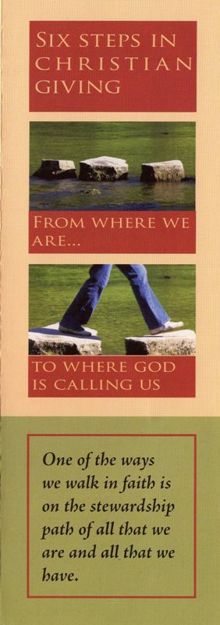
It is very interesting.

Where do you fit?
Transforming Giving

Even without reviewing what we give, we can review how we give.

Using the planned giving scheme (envelopes or standing order) ensures that our giving is regular.

And signing a Gift Aid Declaration will turn every £10.00 we give into £12.50.

If you pay tax, please sign.
Giving back to God

Transformation

