XXXXX

pic of church

Thanks Giving Thanks

Sometimes it is easy to forget reasons why we give.

There are those who give to the Church because they want it to be there.

There are those who give when they attend – and not at other times.

There are those who give because the Church ‘does good things’.

There are some who give almost as a subscription.

Whilst some give out of Thanksgiving to God from what he has given them.
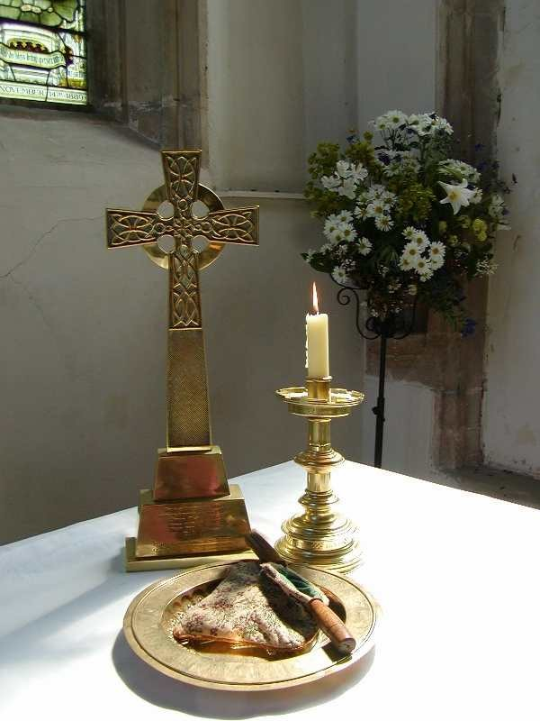
And it is likely that there is a mixture of all of these motivations which combine to make our giving part of our discipleship.

And that journey of discipleship has been undertaken at XXXXX for in excess of XXXX years.

A visible presence of God has been maintained adjacent to the (increasingly) busy main road.

How many people have seen it?

How many people have visited?

How many people have worshipped?

And it is perhaps the worship question which is the most important. For without regular worship taking place in the building . . .

This has been undertaken by people from the area for centuries. Now, in the 21st Century, we meet weekly at XXXX am on Sundays for worship. Whether it is of a traditional form, or of a more contemporary nature, the size of the building and the numbers attending combine to create a unique atmosphere; one which is special and sacred.

All our worship includes prayers of thanksgiving. We join in with these with hearty enthusiasm. Does that enthusiasm translate into our regular offering?

† Can we participate in that without thought?

† Can we participate without prayer?



Overleaf is a page which may refresh our giving.
Something to refresh your giving!
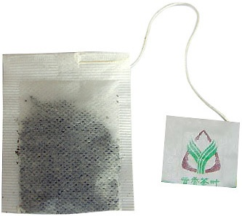
As part of Giving for Life, we are all encouraged to refresh our giving. How can a tea bag help?

It tells us about:

Proportionate Giving
Giving of what we have – not what we have not.
The Church requests; the Bible says.

Planned Giving

Giving first from income ‘first fruits’ – standing order or envelope.
Plan for Government spending where you want it spent.

Prayerful Giving
Talk to God about your response to his gifts to you.
Offer thanks in this time of prayer.

Personal Giving
The response to the first three sides of the tea bag is this!
We respond to God as we are called and as we are able.

2 Corinthians 9:7 ‘God loves a cheerful giver.’ And we all know that lukewarm water infusing a tea bag makes for a cheerless cup of tea.

What does this mean for me?

For 20XX:

our income was £XXXXX
whilst we spent £XXXXX with all bills paid

but, to ensure continuance of presence, we all need to review our giving. It looks a big gap, but it is approximately £XX per week per person on the Electoral Roll. Easy for some, harder for others. Having re-read the ‘tea bag’ page, what will your response be?
With this booklet is a pledge form and a bank Standing Order form. Can you complete them as you are able and bring them to Church on date?

For those who do not want to use a bank Standing Order, we will have planned giving envelopes available.

And, if you are worried about what to do if a collection plate appears, we enclose something for you to use – and a supply will also be at the back of Church.

Finally, for those who pay tax, please tick the Gift Aid box. Please do not forget tax thresholds; changes have occurred so please check your tax position.

Thank you for reading.
Thank you for responding.
Thank you for you.

