XXXXX

20XX

Giving Review

All good gifts around us
Are sent from heaven above
Then thank the Lord
O thank the Lord
For all his love.

It seems appropriate to put the chorus of a Harvest hymn on the cover of a booklet which encourages us all to look at giving.

This booklet is being distributed to all who have a link with the Church in our village. They are those who exercise their faith here.

The booklet is being distributed at Harvest time. That also adds a reason.

The main reason is the Giving Review – a review of
Why
How
What

we give back to God through this Church in our village.
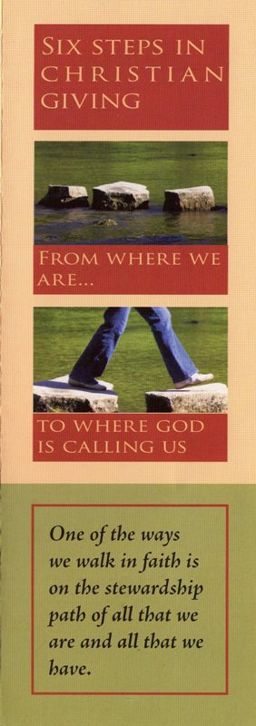
Why we give

With this booklet is a leaflet, entitled ‘Six Steps in Christian Giving’. This leaflet is not unique to XXXXXX. It does reflect many people’s experiences.

- Yes, we probably recognise that God is generous.
- Yes, we probably know that we should say thank you.
- Yes, we should ‘do’ thank you as well as say it.
- Yes, we sometimes find this hard, and
- Yes, sometimes we can’t.

Please read the leaflet, sing the chorus on the cover of this booklet, and talk to God in prayer.
How we give

The traditional way is to use the collection plate when we come. The better way is to plan our giving by setting aside a portion of our income to say Thank You to God.

Some people use envelopes, whilst an increasing number use a Standing Order form. This enables us to put God first in our budget – and we do not have to search for some money on Sunday.

If this is how you would like to give, a token, to put in the collection plate, can be available if you would like one. Changing how one gives can be difficult.
What we give

Biblical teaching is consistent. Those with more should give more than those with less. This is sensible. It also requires us to look at what we have and not what others have that we do not.

What we give, as with why and how, should be a matter for prayer. It has to be a matter for personal decision and action.

Proportionate Giving (those with more giving more than those with less) is often seen as a target to achieve. In the early Church, it was also spoken of as a means of ensuring that believers did not give too much!!
What to give in XXXXX

Quite often, people like to know how much things cost. Money given to our Church is used for:-
£
Parish Share (pays for clergy,
helps poorer parishes, etc) xx.xx
Insurance and Utilities xx.xx
Giving away to others less fortunate xx.xx

TOTAL xx.xx
per annum

With XXX members, this works out, per member, at: £ xx.xx per annum
£ xx.xx per month
£ xx.xx per week.

Some could give more; some not as much.

If we all took prayerful giving seriously, what is needed would arrive.
How to give in XXXXX

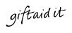
With this booklet is a response form. You can ask for envelopes or you can complete the Standing Order form. If you pay Income Tax, we can Gift Aid your giving, providing you complete a declaration. This will increase the value of your gifts by 25%.

In 20XX, this was worth £xxx to our parish. If all giving had been Gift Aided, we would have received an additional £xxx which would have helped towards our deficit.
Why to give in XXXXX

The thank you to God reason has to be first and always should be.

In 20XX, trusts from outside the village gave us £XXXXX towards the roof repairs. If those from outside the village can be so generous, we perhaps should look at our own response as well.

Likewise, previous generations have ensured that there has been a constant presence in the village for over 900 years. We must now take responsibility. Have you ever realised ME is WE partially turned upside down?
Other things which are important

† The why, how and what to give questions can also apply to our Wills. How would yours express your faith? This is a question we should ask when we update our Wills.

† Major building repairs can be grant funded.

† Grants are easier to obtain when it can be seen that a church meets day-to-day expenses.

† St Paul reassures (and challenges) us that we are welcome whatever we give, provided that it is with a generous heart and from what we have.
Thank you . . .

For being part of the Church in XXXXX

For what you give in money

For what you give in time and energy

For your prayers

For reading this booklet

For your response to say:

THANK YOU GOD

This booklet and the response forms are for you. There are packs for everyone and there are a number of folders journeying around the church family.

- Please pray about and make your response.

- Place your response envelope in the folder and pass the folder to the next person.

That way, we can all respond as we can.

Thank you for reading the information.

Thank you for prayerfully considering your response.

Thank you for completing the response form.

Thank you for being part of our Church.

O Lord, help us to go out of ourselves, so that we may give ourselves over to you, with all our powers, with all that we are and all that we have. Amen

Jacob Boehme

