

Giving for Life

20XX

Parish of XXXXX
Review Giving

It is important that we review our giving on a regular basis. This is because our income changes. Sometimes these changes are gradual, but cumulatively they may mean that the proportion of our income which we give back to God through the Church is not what it was. The Church has encouraged a level of giving of 5% (5p in every pound) of income for at least the last 50 years.

If your income has gone down since you last reviewed your giving, you must reduce your giving.

If income has increased, your giving should adjust in line, whilst if your income is identical then that is the result of your review.

Reflect on 2 Corinthians 8:12. It reassures on the result of a giving review yet challenges on the attitude of giving.
Renew your Giving

All of us can renew our giving. A personal prayer of renewal/dedication could be said as you seal your response envelope. All responses will be dedicated on date.

Renewal can also include how we give; completing the Gift Aid declaration if we can, as well as developing the willingness and eagerness indicated in the reflective verse on the previous page.

Renewal can also include worship; service and prayer. Can you manage:-

One hour of worship ) offered to
One hour of private prayer ) God each
One hour’s service ) and every
One hour’s income ) week?

Reflect on Isaiah 11 v 2 – 3. We all have these gifts. How do we use them?
Rejoice in your Giving

It is all too easy to think ‘I have not got as much as Mr XYZ, therefore I am not wealthy.’ A more valid response is to look the other way and see what you do have. There is local, regional, national and international poverty and deprivation. In XXXXX, we may not be in the spheres of Mayfair and Park Lane, but neither are we urban inner estate with all the difficulties associated with that environment.

Looking at:-

- what you have
- what you are able to give
- what you have left after a realistic level of giving

enables a sense of joyfulness – even as the country painfully exits recession.

Reflect on 2 Corinthians 9:7. How does your joyfulness measure against this?

The Church of England has launched Giving for Life. It is a challenge to all parishes – urban and rural – to look at planned giving. As parishes are people, that means you and me – us. A leaflet is enclosed for you. A legacy leaflet is also enclosed, as November is ‘Will Aid’ month – an initiative of charities.
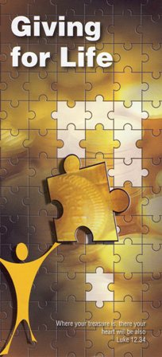

We will be holding our commitment celebration service on date. All responses to our Giving for Life initiative will be offered at the altar at our xxxx am service. Please use the response form in sufficient time for it to form part of this act of worship.
Parish Budget 20XX

We intend to spend:

£
Mission and Ministry .
Running costs of buildings .
Routine repairs to buildings .
Supporting the less fortunate .
________

£ .

And for 20XX, it would appear that our income will be
£ .

This equates to a shortfall of £xxxxx per month (£xxxxx per week) – something that we can bridge if we all give what we can.

