Parish of XXXXX

R

eview
ealise
ejoice

in our giving

Giving back to God invokes many emotions.

- I can’t
- I already do
- I give all I can

are all common reactions.

Stop for a second.

Where would the Christian faith be if Jesus had reacted in such a manner?

- No Good Friday
- No Easter
- No Ascension.

Nevertheless, these are difficult times for some and what is already given is greatly appreciated and put to good use.

The parish, as with households, faces changes to circumstances, both income and expenditure, and it is because of this that we are asking all connected with the parish to review their giving.

Review means just that. To review:

- what
- how
- when

we give in recognition of God’s continual giving to us.

‘What’ is a matter of prayer and action.

A response card is enclosed.

The ‘how’ is also important.

Participation in the planned giving scheme, whether by bank standing order or envelope. Those of us who pay Income Tax can use Gift Aid to enable a tax refund to be claimed by the parish and those who do not pay Income Tax can put God first in their budget.
The ‘when’ should be on the day that our income is received – putting the first fruits teaching into action.

¹ When you have entered the land the LORD your God is giving you as an inheritance and have taken possession of it and settled in it, ² take some of the firstfruits of all that you produce from the soil of the land the LORD your God is giving you and put them in a basket. Then go to the place the LORD your God will choose as a dwelling for his Name ³ and say to the priest in office at the time, “I declare today to the LORD your God that I have come to the land the LORD swore to our forefathers to give us.” ⁴ The priest shall take the basket from your hands and set it down in front of the altar of the LORD your God.  Deuteronomy 26: 1 - 4 | ¹Now about the collection for God's people: Do what I told the Galatian churches to do. ²On the first day of every week, each one of you should set aside a sum of money in keeping with his income, saving it up, so that when I come no collections will have to be made. ³Then, when I arrive, I will give letters of introduction to the men you approve and send them with your gift to Jerusalem. ⁴If it seems advisable for me to go also, they will accompany me.  1 Corinthians 16: 1 - 4

There has to be an element of realism in our personal review. It is very easy to look at what we have not got, rather than what we do have.

Our parish is in one of the wealthier areas in the country (source www.neighbourhood.statistics.gov.uk) in one of the wealthier countries in the world.

The average level of giving across the Church of England in 2017 was £13.00 per week.

This realism in resourcing the mission and ministry of the Church follows precedent set during Jesus’ earthly ministry.

³ Joanna the wife of Cuza, the manager of Herod's household; Susanna; and many others. These women were helping to support them out of their own means.
Luke 8:3

This passage shows ordinary people resourcing mission and ministry.

The parish has benefitted from bequests and these have been used for a variety of purposes.

It is important that we all review our Wills from time to time. A leaflet, which speaks about legacies, is enclosed.

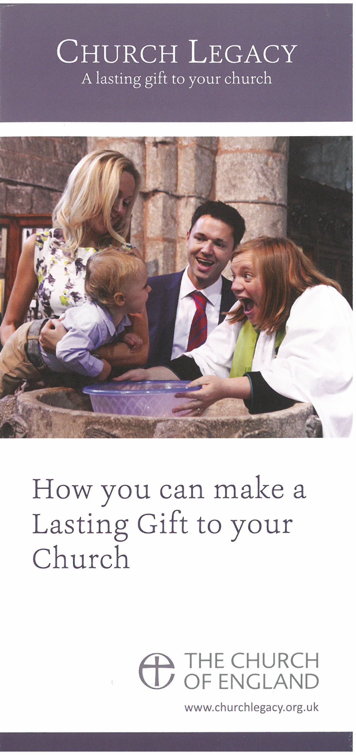

Rejoice – the final and most important R in this booklet.

If we all realistically review our giving, we can all rejoice knowing that the parish can move forward.

And if we all review our giving with a sense of joyfulness and gratitude to God, we know that the parish will move forward.

Will you, will we?

You will, we will!
What happens next?

This booklet has been prepared by a small group of people within the parish. We hope that you have found it of interest.

Please think about your response and then use the response slips provided, remembering to complete your name and address. The envelopes in which you can seal your response will preserve confidentiality.

When you have made your response, please pass the folder to the next person on the list. There are several folders travelling around the parish so that all who are connected with the church have a chance to take part.
Prayer from parish

