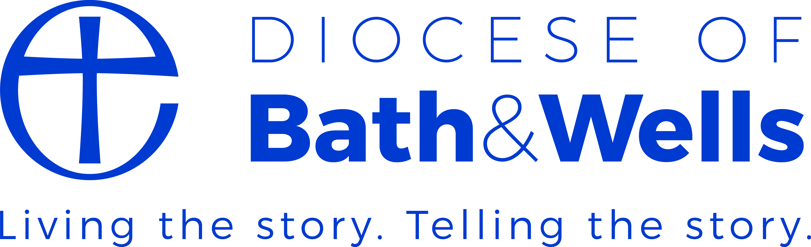
Children Leading Collective Worship in schools

General Points:
- Collective worship is the entitlement of all staff and children and where possible, others within the school community.
- Children can genuinely add something precious in planning and/or leading collective worship.
- Clergy may like to experience being a part of collective worship, not always leading it, especially if children are planning and leading it. It helps clergy get a sense of the ‘spiritual temperature’ of the school.
- Children planning, leading and evaluating the impact of collective worship will be an evolving dimension of your work as a church school.
- This dimension will need to be fully discussed with staff, governors and clergy and to be written clearly into your school collective worship policy.

To consider:

Planning
- Having a planning sheet that the children can use is useful (Resource available as an appendix).
- How can you minimise staff workload? You do not want staff checking this with the children one lunchtime every week! There will be an element of risk but with good training at the start for those children who are eligible to offer to be involved, this should be a small risk.
- Which children can offer to plan and lead a service? This depends on the context of your school. You may offer the opportunity to the eldest year group or you may offer it to a key stage.
- What worship time can they lead? Will this be a class, phase or whole school collective worship? Again, this depends on the context of your school, such as the size of your school and how you usually plan across the week.
- How often will there be an opportunity to lead? Will this be once a week and children sign up or less regularly. One tip is the more often they have the opportunity, the quicker this dimension will evolve in your school.
- What degree of choice will the children have? Will your collective worship planning group decide on the weekly themes (eg. values) and the children will sign up for one they would like to do? Will you leave gaps in your theme planner for children to choose some themes? Again, you may like to start more safely and develop this over time.
- Consider the resources available to the children. This may be something that they can help to evaluate over time but will include children’s Bibles, children’s prayer books, music and songs.
- Once you have decided how you want to organise this, you can arrange a short training session for those who are eligible. If for example the Y6 were eligible, a short 20-30 minute training session can be given during class time. It may be useful to have a refresher once a term as the childrens’ questions may become more advanced and indicative of their growth in thinking about invitational, inspirational and inclusive practice. Some schools have found the ‘Lighting the Candle’ resource from Truro diocese helpful in training children (Resource kindly available from Truro Diocese on our website).

Leading
- The structure should support the children in leading so that there are some common practices. The GERS model works well, and some commercial resources support this, eg. ‘Flippin’ Praise’. (Resource information sheet available on our website) As a school you could create your own GERS structure; Gathering, Engaging, Responding, Sending.
- As part of the ‘Gathering’ and the ‘Sending’ you may like to consider what liturgy you will use as a school. This may include several options for the children to select from.
- Also, as part of the ‘Gathering’ and ‘Sending’, your school may light a candle. If you do, clarity over the safety of this process will need to be thought through.
- Leading in partnership is always helpful whether it is children leading or adults new to leading. In the same way that a child leading on their own is probably too challenging, so is a large group of children leading together, unless it is very well planned like it would be for a whole class ‘assembly’.
- It would be helpful for there to be a staff point of contact near the children leading in case of crisis. It probably won’t be needed, but better to be prepared and for the children to know that you are there if they are concerned.
- The children’s ability to lead collective worship will evolve over time. Don’t give up if in the beginning it is a bit strange!
- This is not about performing. Helping children to understand the essence of collective worship is key. You, clergy and others will have modelled it, they will have seen and experienced it.

Evaluating
- The vision of a church school is that all children and adults flourish – does collective worship have an impact on this? How do you know?
- Within strand 6 of the SIAMS Schedule, the key inspection exploration is into ‘The way in which collective worship is an expression of the school’s Christian vision’. Evaluation needs to be focussed on this too.
- The context for collective worship is that it is inspirational, invitational and inclusive for the whole school community – it could be useful to evaluate against this. (See appendix)
- Sometimes the word monitoring results in only looking at the content of the collective worship session, like the stories, prayer and songs used, whether it was too long or not long enough. These are only important if they have any relevance to the impact on the school community.
- It is a good idea to come up with an evaluation strategy which includes who, when and how; options include worship leaders, an evaluation book with key questions, an impact sheet, reflection question back in each classroom. This will then sit within your wider evaluation strategy which will include staff, governor and perhaps parent feedback.
- There are plenty of good examples of monitoring sheets, such as the snowflake activity from Rochester Diocese (Resource available as a link on our website as part of the Monitoring Guidance). The most important thing is that you think ahead about what you are monitoring, what the questions are, and how these could have an impact on the quality of collective worship.
- Your foundation governors may want to ask whether the children have found that monitoring, discussing and evaluating the impact of collective worship has resulted in any changes?
- Another important question is how evaluating the impact of collective worship has identified strengths for your school, or aspects that you would want to ensure become embedded.
Enjoy!
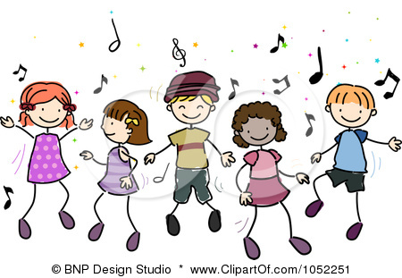
Children Planning Collective Worship
This Photo by Unknown Author is licensed under CC BY-NC-ND

Children’s names:
Date:
Theme:



Gathering
You may choose to light a candle, use liturgy, play some music or have something visual for children and adults to see as they come in.
Engaging
You may choose to sing or share a story, either from the Bible, fictional or from life today or in the past. There may be something happening in the media or school that you want to share.
Responding
You may like to respond as a group leading or ask others to join you in singing, sharing a poem, music, or dance.
You may have a time of quiet or reflection or have a time to respond in prayer.
Sending
You may like to have a Bible verse or thought / challenge for everyone to take away with them in their thoughts. You may share some liturgy or blow the candle out. You may have music as everyone leaves.

This Photo by Unknown Author is licensed under CC BY-NC-ND
Children Evaluating the Impact of Collective Worship

Children’s names:
Date:
Theme:

Our School Vision:
Have you seen or heard about how this collective worship has made a difference to your school vision?

How did collective worship being inspirational make a difference? | How did collective worship being invitational make a difference? | How did collective worship being inclusive make a difference?
Do you think this collective worship helped children or adults to flourish (feel really good about themselves and life)?

How do you know?

Are there any other ways you know about where this collective worship has made a difference to someone?

