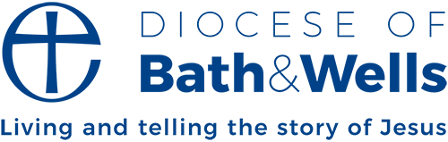
DBS Update service FAQ

What is the update service?
The update Service is provided by the Disclosure and Barring Service (DBS) and allows individuals to share their DBS details without having to complete additional checks.
This means that a certificate registered with the update service can be checked through the update system which will reveal if any new information has been found since the check was initially carried out.
If the initial check was clear and the update check provides no further information, you can use the existing certificate as if it were issued on the date the update check was completed, and it will remain valid for 3 years.
If the check reveals that new information is available, a new DBS check will need to be carried out.
This service is currently not available for Basic DBS checks.

How much does it cost?
The update service is free for volunteers.
For a paid member of staff, there is an annual recurring fee of £16.

How do I register a DBS certificate on the update service?
You must register your DBS certificate within 30 days of it being issued.
You can register for an update service account here: DBS Update Service - GOV.UK
You can use either your application reference number or certificate number to register. You will need to provide some basic information and, if the certificate is for a paid role, payment card details. Once completed, your account will be created and your certificate added to the update service.

How do I perform an update service check?
- Contact your local PSO or member of C of E clergy and ask them to fill out this form: Update Service Access Consent Form.docx.
- You must provide your original paper certificate to your PSO/Clergy member for validation, and you must ensure that the existing certificate has an appropriate level of check for the new role you will be undertaking (for example, if you will be working in regulated activity with children the check must be enhanced with child barring).
- Once the form is complete and the original certificate has been seen, you can either send a scanned/photographed copy to the DBS inbox at: dbs.safeguarding@bathwells.anglican.org or send it via post addressed to the safeguarding team to:
Flourish house
Cathedral Park
Wells
BA5 1FD
- The safeguarding team will process the check and inform you of the outcome (wither no additional information is available and the certificate can be used as is, or a new DBS check must be carried out before proceeding with recruitment).

How can I check which certificates I have registered?
You can log into your account using your Update service number (e.g. C1234567890) and manage, add, and remove certificates from here.

