Eco Church Case Study

Holy Trinity Church, Yeovil

History and use
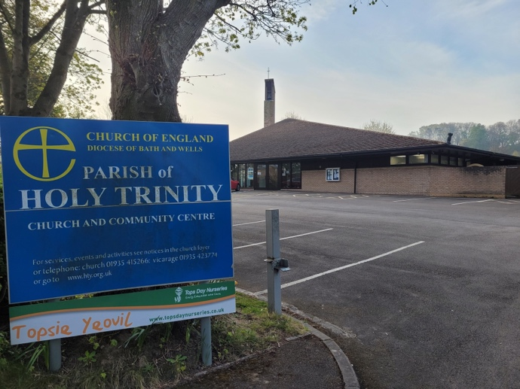
Holy Trinity Yeovil (HTY) was built 25 years ago on the western side of Yeovil. It replaced the original Holy Trinity in the centre of the town (which was converted into residential accommodation) and St. Mary’s on the western edge which was condemned. It forms part of a benefice with sister church St. Mary Magdalene in Barwick, which is a 13th century grade 2 listed building in a small village.

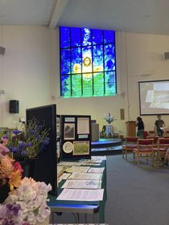
The church hall is used throughout the week by preschool and at the weekends by a range of regular users. The remaining spaces (offices, church body and meeting room) are also rented out often, especially in evenings.

The church is built connecting to the local, large primary school and the school attends a service within the building once a week. Main services are on Sunday and prayer meetings and Church Mice (parent and toddler group) meet during the week. Other regular users include Mothers’ Union, Women’s Institute, a community choir and ballet. The church also hosts a baby bank for expectant and new parents in need of assistance.

Building sustainability

HTY was awarded a Silver Eco Church Award in 2021 and is working towards Gold.

When HTY was built, it was designed with sustainability in mind with a sloping roof, adaptable space and compact windows; however, issues with the roof mean solar panels have not yet been possible. In the last five years all lighting was replaced with LED motion sensor lighting which means lights are not accidentally left on and are the most efficient for the needs and use of the space. Large foldable walls mean the space can be transformed from smaller to larger areas which has enabled differentiated heating and lighting. Almost all toilets have been twinned (with Toilet Twinning) and automatic electric hand dryers were installed to save paper and energy. Water-saving devices were installed in all six toilet cisterns.

Land sustainability

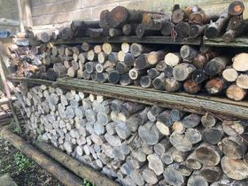
The church benefits from a large wrap around garden space (which is not a burial ground) and a very large carpark. A wonderful gardening team have transformed the space over the last six years into a well-managed and thoughtful space for a multitude of uses with wildlife in mind. The front area suffered from ash die-back and several trees were lost. The team created raised bedding with branches and log piles for habitats for small creatures.

Additional wood was chipped and used to mulch pathways around the beds. It has proved to be an excellent habitat for fungi (particularly the red-edged brittlegill which has thrived this year).

Other key features:
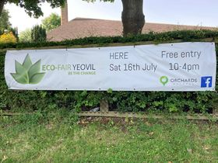
- A new management plan is in place for the front lawn: some areas are being left to grow and mowed twice-yearly to prevent succession and encourage native wildflowers and insects.
- Two large compost heaps are used and maintained in the rear garden.
- Seed, berry and nut-producing native hedgerows and trees which line the perimeter of the site provide food and shelter for small mammals and birds.
- Fruit trees are grown for food for community and nature.
- The garden is used for a wide range of activities and hosts both native and garden species which are managed sensitively for memorial and pleasure reasons.
- The western edge of the garden is managed by the preschool who are a sustainable preschool. The garden is used to encourage wildlife and engage the children in outdoor and nature-based learning.
- It undertakes species surveys with the help of local experts.
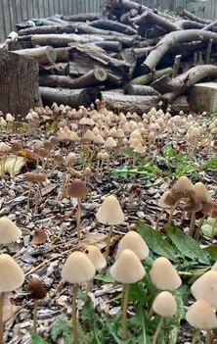
- It is part of the Wilder Churches initiative (a partnership project between the Diocese and Somerset Wildlife Trust).

Worship and community engagement

HTY is a frequently used space and offers wonderful opportunities for engagement and nature connectedness as well as encouraging personal sustainable lifestyle choices. It holds an annual Eco Fair showcasing local sustainable producers and provides talks and workshops from diocesan staff and local organisations.

