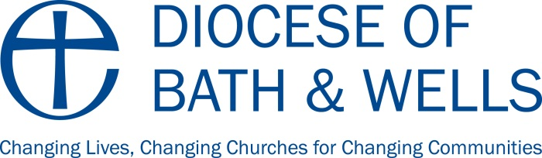

Capital Funding and Capital Works in Schools and Academies

Voluntary Aided (VA) Schools

Devolved Formula Capital Grant (DFCG)
VA schools are allocated Devolved Formula Capital Grant (DFCG) on the same per pupil formula as other schools, but under legislation in the 2006 Education and Inspections Act, VA schools have two options on how they receive their capital grant allocation. They can either opt to have their grant paid directly to them or for the Diocese to act as their banker. Whichever option is chosen, DFCG is paid annually, generally in April but always in time to enable projects to be carried out in the summer holidays when the majority of capital work takes place.

The vast majority of schools opt for the Diocese to bank their DFCG for a number of reasons:

a) The quantum of funding held by the Diocese on behalf of schools enables the money to be invested at a higher rate of interest than would be possible for smaller amounts. Interest on unspent DFCG is sent to schools every 6 months and is of course liable to the fluctuations of the national economy.

b) The VA Capital Team at the DfE requires an end of year assurance form for each school verifying the money has been spent resolving appropriate asset management priorities and confirming that VAT has been paid and governors’ 10% liabilities met. The Hookway Partnership (Surveyors for the Diocesan Education Department) maintains an accurate record of all capital projects undertaken for schools who bank with the Diocese and ensures the end of year assurance forms are accurate and returned to the DfE on time.

c) Schools cannot save DFCG for more than 3 years under normal circumstances without that money being liable for reclamation by the DfE. The Hookway Partnership ensures that all funding for schools who bank with the Diocese, is pulled down in a timely manner and alerts schools if there is any danger of losing DFCG under the ‘3 year rule’.

d) Schools who opt to bank their own DFCG take responsibility for checking and paying invoices; recording and monitoring expenditure and balances and for completing and returning end of year assurance forms.

Locally Coordinated Voluntary Aided Programme Funding
This is currently the only other form of funding available from the DfE specifically for voluntary aided schools. This funding is for capital projects beyond the reach of schools using only their DFCG. It is allocated per local authority, based on a formula related to the number of pupils attending VA schools (both Anglican and Catholic) in each authority. The funding is allocated strategically by the Dioceses and LA according to asset management priorities. This funding always has to be spent in the financial year for which it is allocated.

Governors’ 10% Liability for Capital Funding
The governing body of any VA school has a statutory liability to pay 10% on any capital works using DFCG or LCVAP funding. Once a building project has been agreed, the governing body will be invoiced for the full amount of its liability. Governors must raise 10% of their DFCG allocation EVERY year eg. £700 for a £7,000 allocation. Governors must therefore be able to meet their liability before undertaking a capital project. The Diocese is able to offer a 1, 2 or 3 year loan for this liability to spread the burden for governors. This is currently offered at 1% above base rate. An application form is available on request.

Services Management
Governing Bodies in VA schools are responsible for ensuring that all legal, statutory requirements are complied with regarding the servicing, maintenance and testing of equipment within the school.

In order to effectively manage these requirements, schools may wish to subscribe to a service management contract. Some subscribe to Local Authority Building Maintenance Indemnity Schemes (BMIS), some have contracts with independent property management companies and some subscribe to The Hookway Partnership Service Management service.

It should be noted that the success and thoroughness of any such service is dependent on schools notifying their provider of their needs and providing a comprehensive list of all contracts etc that need to be managed.

It remains the responsibility of the governing body to ensure the service provided complies with legal and statutory requirements so please check with your service provider if you are unsure.

Voluntary Controlled (VC) Schools
Arrangements for capital funding for VC schools is through the Local Authority. DFCG is calculated in the same way for all schools and academies.

Academies
Academies receive DFCG directly from the Education Funding Agency (EFA) but can also bid periodically for further capital funding. This is usually heavily oversubscribed and with some particular focus. Academies complete a generic bid form. There is no 10% liability even if the academy was a former VA school.

