How to complete the Energy Footprint Tool

Before you start this process, please know that you will need the following information:
A figure for energy use for the year (January 1st – December 31st 2023). This can come in the form of kwh used and or cost. Ask your churchwarden or treasurer to see your energy bills for the year.

The following information is completely optional:
Inputting this can give you a more accurate footprint calculation and provide us with valuable information as to how your church and heating is used.
- Your energy supplier.
- Whether you have single or three-phase electricity.
- Estimated number of miles OR money claimed for work-related travel across the year.
- Cost of your miles that were conducted via public transport.

Logging in to the system
- Please visit https://parishreturns.churchofengland.org/
- Click “Login to enter or view your data” and enter your details.
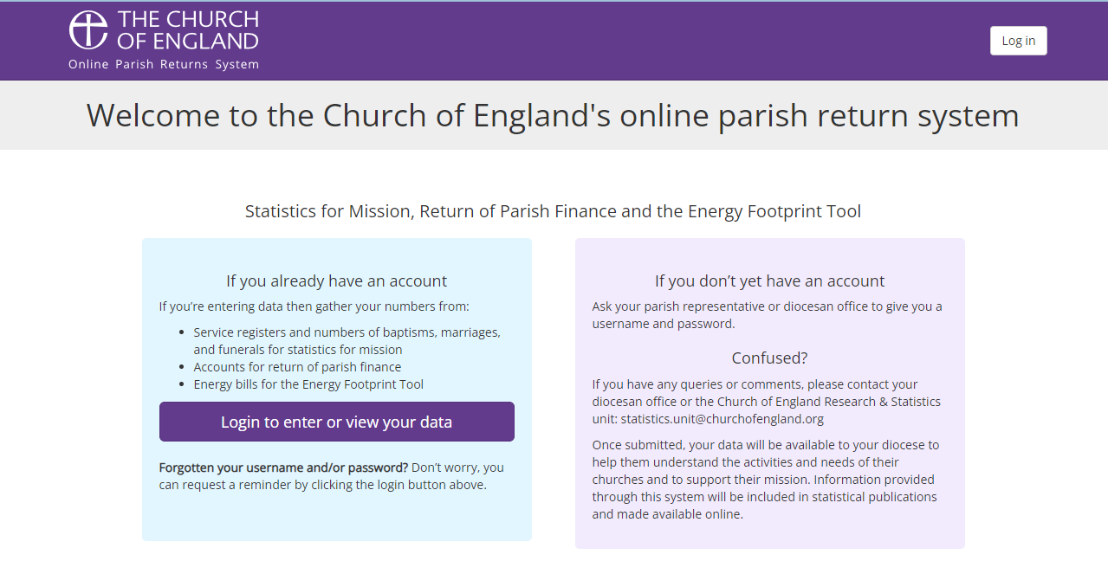
If you do not have a username/password, or have forgotten them, please contact your Diocesan Net Zero Enabler (Dan) – dan.wills@bathwells.anglican.org.uk/07904464611

Entering your data
Once you have gained access to your portal:
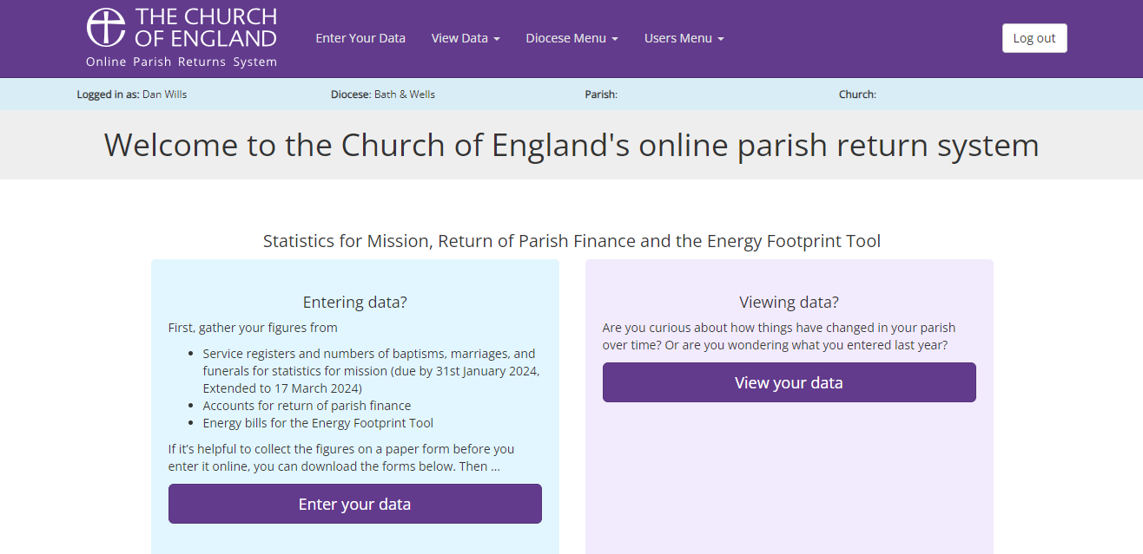
- Click “Enter your data” and then click the green “Enter your data” button under the “Energy Footprint Tool” header

Buildings and Fuels Used
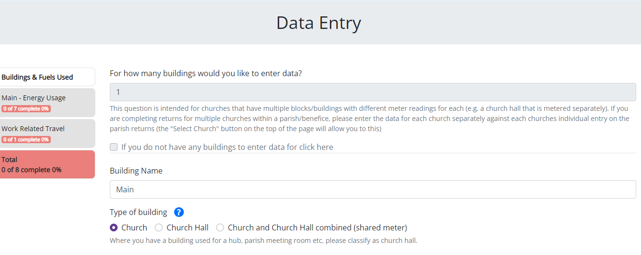
The first question asks: “For how many buildings would you like to enter data?”. This is for if you have multiple buildings or blocks, with different readings for each. This will multiply the form to allow you to enter your data for the different buildings/blocks. Remember – this section is NOT for inputting a separate church building in the same parish/benefice. There is one Energy Footprint Tool per church. If you are struggling with multiple logins – please contact Dan.
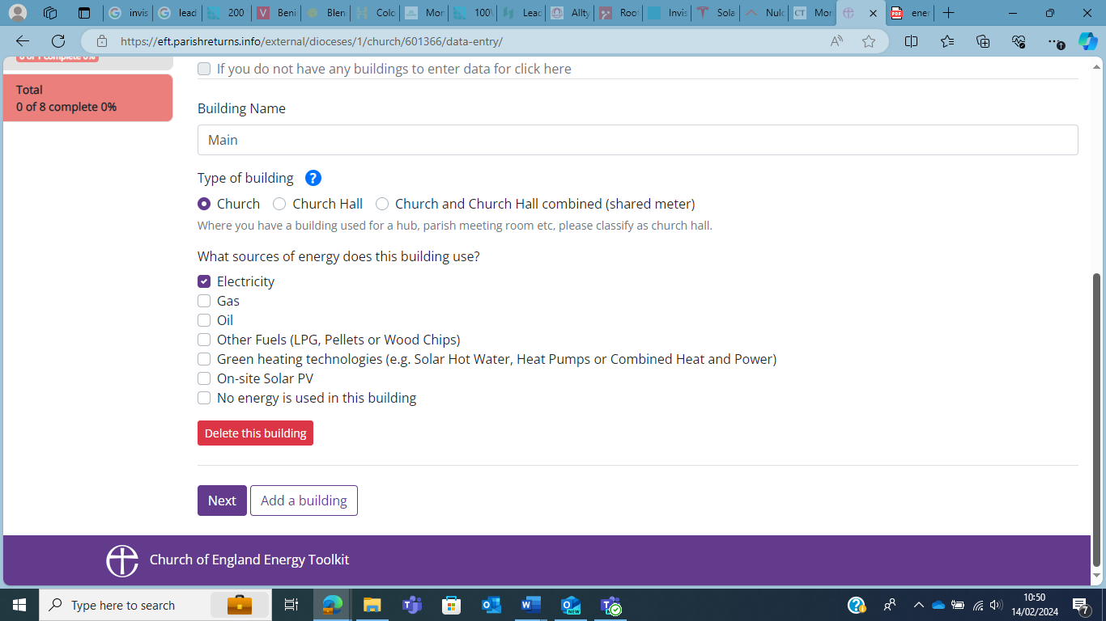
Next, select the type of energy source your church building uses, and if applicable, repeat this for your other building(s). You can select multiple energy sources.

Energy Usage
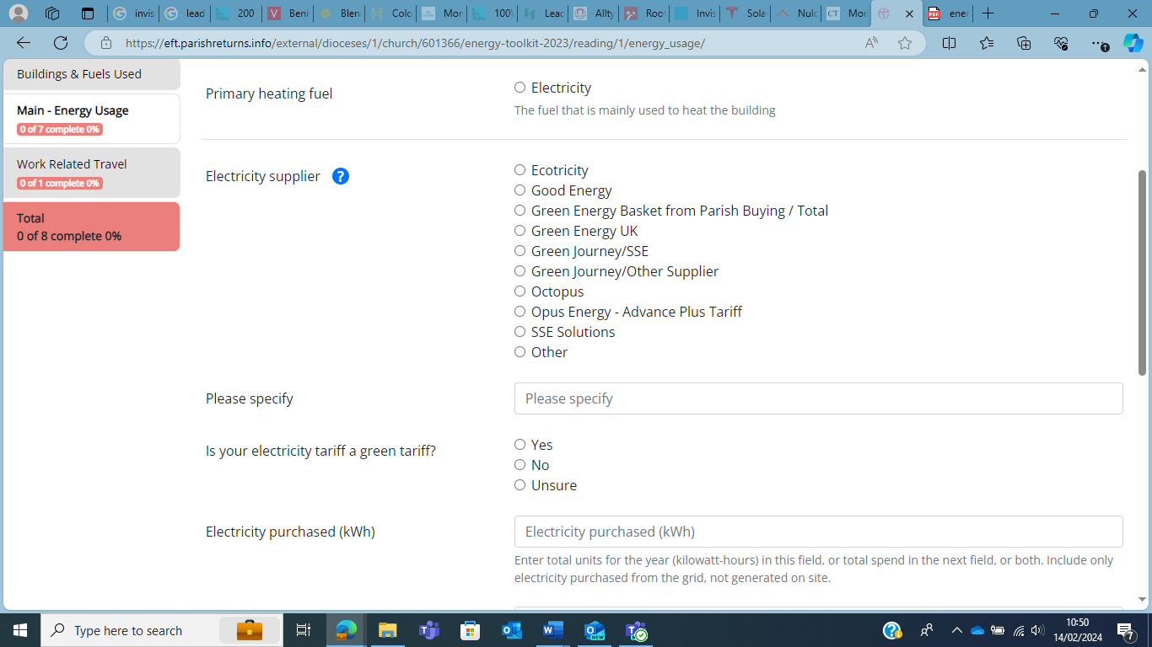
On the ‘Energy Usage’ page, please enter the relevant energy information, where possible. Starting with the primary heating fuel (will be a list of energy sources selected on previous page), select the fuel you use most frequently to heat your building. Then, enter your energy supplier, and whether or not you have opted for a ‘green tariff’. Next, you can enter the total energy you used in 2023 in either kWh annually, or the cost of the annual energy type in £.
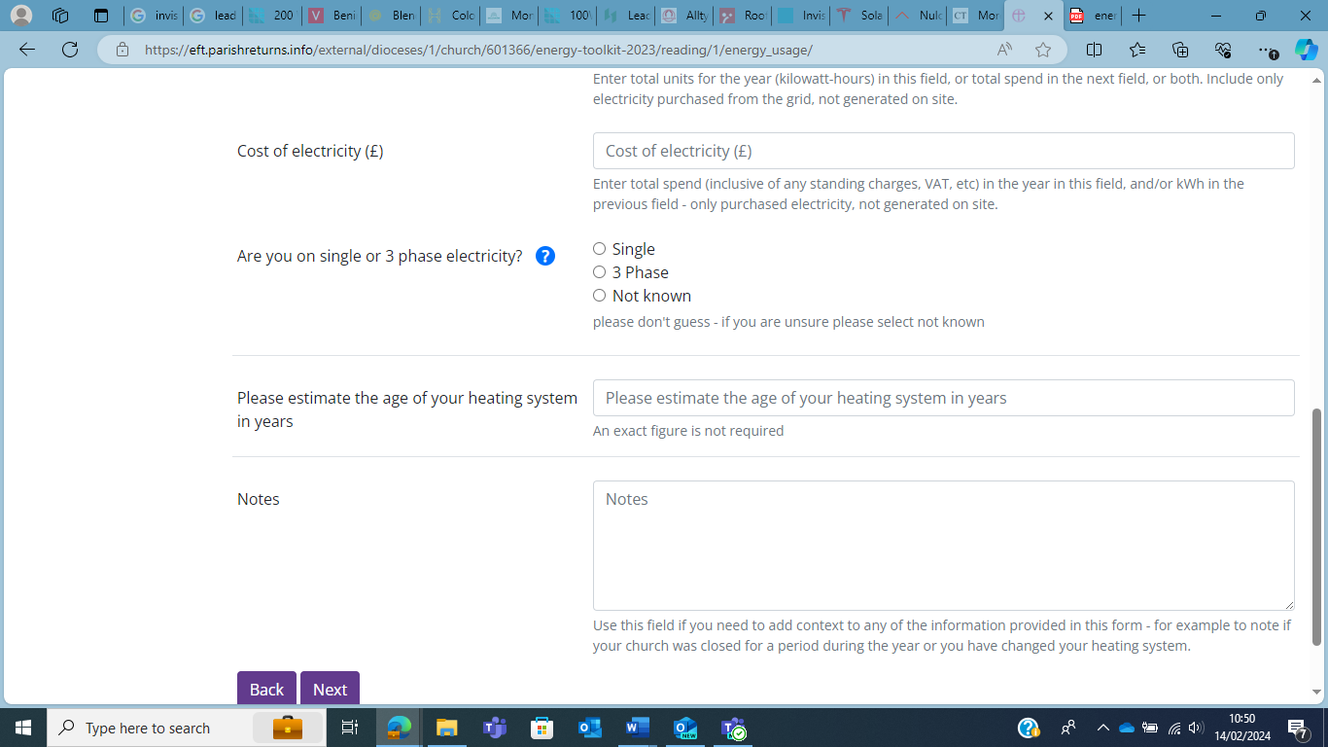
There are new features on this year’s EFT. Firstly, do you have a three phase or single-phase electric supply? You can find this out by checking your fuse box and, typically, if you have three 100-amp fuses, you have three phase, anything less, you likely have single phase. Secondly, please try and estimate the age of your current heating system. Finally, you can add any additional notes that might help us understand how you heat your building.

When moving on to the next page, you may get a message of “Are you sure?” if there are any blank spaces. If you do wish to continue, please do press the “Continue” button.

Travel Data
Unlike last year, this year you do not have to input information about the size of your church and the number of people who attend. Upon continuing from the previous section, you will go straight through to the ‘Work Related Travel’ section.
This section covers whether any work-related travel expenses claims were made in the past year.
- If yes, how much? – The answer can be given in either Number of Miles or Cost Claimed (£).
- This year, there is the option to input what percentage of total miles were conducted in an electric vehicle.
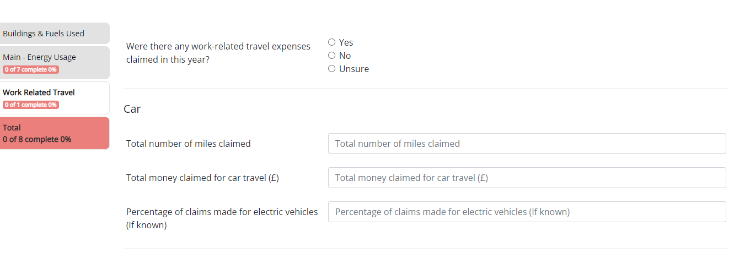
- Again, if the information is not easily found/known, please do not spend too much time on this question and either guess or leave it blank.
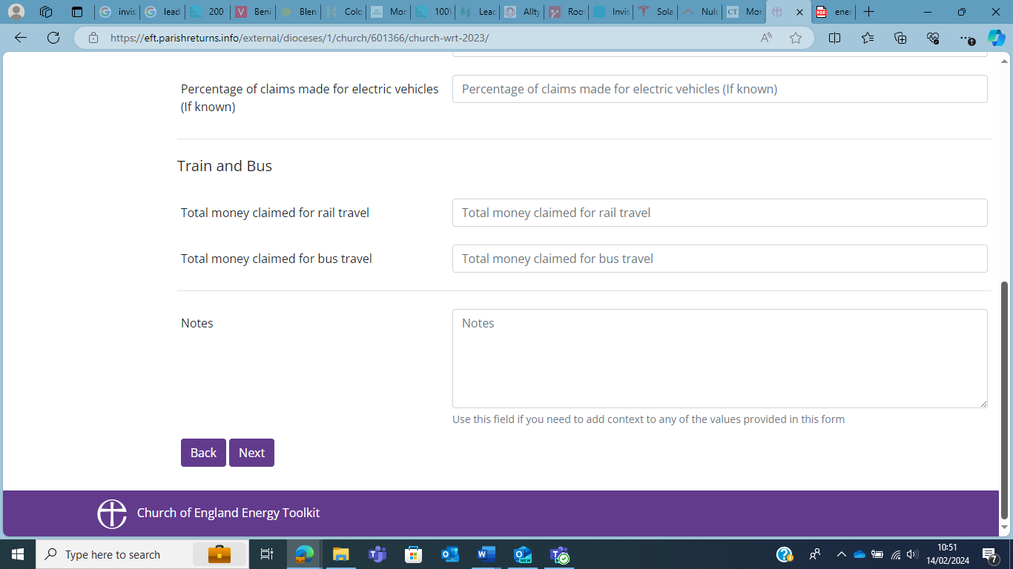
Another new addition this year, if any work-related travel was done via public transport, you are able to input the money claimed for that also. Again, you can put more specific details in the ‘Notes’ section.

Calculating a carbon footprint
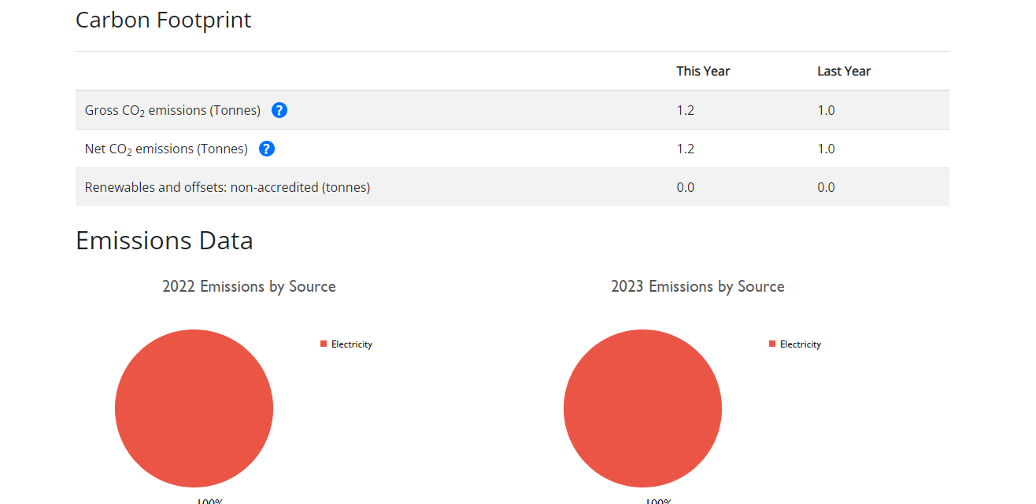
Upon clicking ‘Next’, you will be moved to another page, informing you that you have completed the Energy Footprint Tool. If the ‘essential’ information has been inputted, a carbon footprint for your church will be calculated, and if you scroll down, you should see your footprint. A new addition this year, there are now graphs and tables, highlighting what percentage of your emissions come from which energy source, as well as how your emissions compare from last year.

Following completion of the tool
This year, the completion of the tool will result in your church being sent a certificate detailing your carbon footprint, with a signed thank you from Bishop Michael. This can be displayed in your church. Also, it may be worth looking at the Parish Buying website (Parish Buying - Energy Audit) who will offer a discounted ‘Energy Audit’ as a result of your completed EFT. You can also get in touch with us to find out more about the energy audit options we can offer you. Finally, if you have taken the time to fill in this years EFT, firstly, a huge thank you from us at the Diocese, secondly, whilst our team are working hard to get in touch with each individual church to offer advice … we encourage you to be proactive and get in touch with our Environment Team, and take advantage of our advice. Getting in touch with us will allow us to help you create a routemap to Net Zero, as well as advise on how you can become more energy efficient, reduce your carbon footprint, and even potentially save some money on energy bills!

