Stewards in a Slump : Sermon Notes

Notes for a sermon preached by John Preston, National Stewardship Officer, to introduce the “Stewards in a Slump” booklet in January 2009.

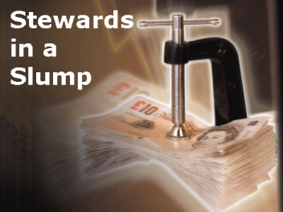 | Opening :  Paint a picture of the current recession, with recent news.  Perhaps include one or two huge statistics such as the following from ‘Times Online’:

A billion isn’ t what it used to be!
1. £500,000,000,000…or around £8,000 each. £500 billion is a conservative estimate of what taxpayers, you and me included, are paying to bail out the UK banking system.
2. £20,000,000,000…This is the amount of taxpayer cash that has gone into the coffers of the Royal Bank of Scotland. This is the equivalent of £333 each.
3. £1,800,000,000,000… £1.8 trillion is the cost to the global economy of the credit crunch. Such a vast number is difficult to grasp, but in the same report, the Bank of England valued the UK economy, the fifth biggest in the world, at £7 trillion. So it has so far cost about a quarter of the value of our entire economy.
Source: http://timesbusiness.typepad.com/money_weblog/2008/12/post.html
Whilst these numbers are huge, though, the Credit Crunch and accompanying recession affect all of us, but in different ways. Some may have lost their jobs, others will have seen pension funds significantly reduced in value. If some of us are relying on savings income, that will have reduced significantly as the Bank of England base rate is at its lowest since the Bank was founded in 1694, others may find it hard to renegotiate loans or mortgages. Whoever we are, however much or little we have, we are, and will be, affected by the current recession. Today’s talk explores how we might view this differently as Christians.

The key aim for the opening of the talk is to paint a picture of the global nature of the credit crunch, its severity, and that individuals are affected in different ways, and to lead into a distinctively Christian perspective on the recession.

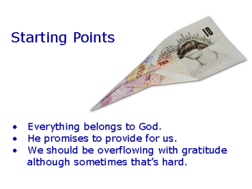 | Slides 2 - 4 reveal the three different starting points, one at a time. These points mean that we should be able to come at hard financial times with a different perspective. What we have is the Lords, rather than ours; and given his promises of provision, we need to learn trust and thanksgiving.

Our faith means that we start from a different place from others. Let’s have a look at some of the things that might make a difference to how we view our money during a recession.
Firstly, in one sense, it isn’t our money! It’s God’s money. The Bible tells us that everything belongs to God. Psalm 24 begins “The earth is the LORD'S, and everything in it, the world, and all who live in it.“

God’s ownership is different from human ownership, though. Human ownership is a jealous ownership. If it’s mine, it isn’t yours!! Hands off!! But God’s ownership is a shared ownership - it is Gods, but it is also ours to enjoy, to take care of, or as we might say “to steward”.

Secondly, God promises to provide for our needs - not necessarily our wants, but to meet our basic human needs. Trusting him to do this can be hard, particularly if we’ve become very self reliant. Matthew records Jesus telling his audience not to worry about the material things of life, what we will eat or drink, or our clothes, or even our health.

Conversely, if we can appreciate all that God has given us, we can become thankful. He has provided for us in many different ways, and our gratitude and thanksgiving needs to take a broad perspective if we are to appreciate the breadth of his grace.

Depending on the audience, it may be appropriate to stress that it can be hard to place our trust in God, and to be thankful, when jobs have been lost, security is threatened and we feel that the world is being turned upside down. Yet it is precisely at these times we need to trust God, and that he is faithful.

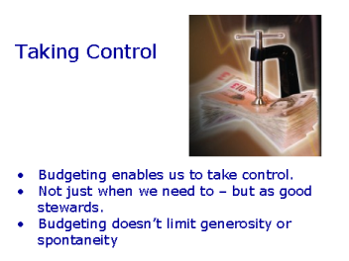 | Slide 5 : Placing trust in God and being thankful, however, does not make us good stewards.  The parable of the talents shows that simply ignoring the responsibility of caring for wealth and other gifts will not please God. To do so requires us to budget.

Most of us hate the idea of budgeting. If we do make a budget, we are likely to do it reluctantly, and because money is tight. Indeed, reaching the point where we no longer had to budget, would for many of us be seen as a financial dream.

Yet if we don’t, a number of undesirable things are likely to occur. Planning our spending is the only sure way for our money to be used where we want. Money tends to leak, largely as a result of successful marketing, creating desires we never thought we had, which we immediately fulfil, often with money we don’t have! The prophet Haggai describes putting money “in a purse with holes in it” (Haggai 1:6) (illustration of a money box without a bottom in it, and pouring coins into it to see them run out onto the floor.)

We tend to find that as our income rises, so does our level of spending. As many people get wealthier throughout their lives, there seems a natural response for our desires to move in line. We want the more expensive car, larger house, branded clothes, gadgets and foreign holidays. Our view of what constitutes ‘a luxury’ changes as we have more disposable income. This often isn’t conscious, and does reinforce the need to budget. To revert to Haggai’s analogy, the more we have, the bigger the holes in our purse seem to be.

Budgeting enables us to take control, and to be better stewards. When things are tight, it enables us to keep track of our spending, when times are good, it enables us to identify whether there is some money available to use for other things such as saving, giving or treating ourselves.

Budgeting doesn’t limit our generosity or how spontaneous we are with our giving, though. Perhaps quite the reverse. If we keep track of money coming in and out, we will find it easier to think through a generous gift - one of the advantages of giving away a proportion of our income is that it is precisely that - one pound to give away, for every nine that we keep, (or whatever proportion we use.) in good times and in difficult times.

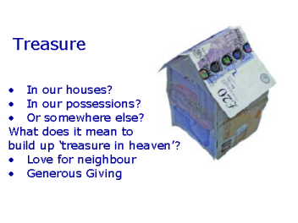 | Slide 6 : This links back to where we started. As Christians we should view the world differently.

Christians should have a different world view from others. The world around us places a high store on wealth, and links it to possessions - it seems to want to define us by what we own – it suggests that the more we have, the happier we’ll be, the greater fulfilment we’ll have and it implies we’ll be a better person for it.

Media and advertising bombard us with messages about ownership and consumption – just spend a little more, achieve the bigger house, faster car, newer phone, designer gear…. And you’ll be a better person for it; they seem to say!

Jesus challenged his listeners about where they stored up treasure. Matthew records him saying this: Do not store up for yourselves treasures on earth, where moth and rust destroy, and where thieves break in and steal. But store up for yourselves treasures in heaven, where moth and rust do not destroy, and where thieves do not break in and steal. For where your treasure is, there your heart will be also”

In his New Year message at the start of 2009, the Archbishop of Canterbury said, “Jesus said where our treasure is, that's where our hearts will be. Our hearts will be in a very bad way if they're focused only on the state of our finances. They'll be healthy if they are capable of turning outwards, looking at the real treasure that is our fellow human beings.”

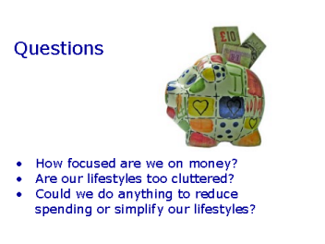 | Slide 7-9 : These slides pose some challenging questions. They are not intended to engender guilt, and the preacher is advised to stress this, but simply to say that it is easy to be caught up with how the world sees things.

And so the recession is a particularly appropriate time to challenge ourselves with these questions. There is no intention of causing any guilt - to some extent we are all focused on money - we cannot isolate ourselves totally from the culture we live in, and nor should we - as stewards we need to have an appropriate focus on caring for the money that has been entrusted to us.

But it may be that we can identify an area of our spending where we are perhaps too heavily focused on money - unhealthily so. Now when income drops and times are tough, we need to work hard to bring in the money we need for our families or ourselves. That isn’t unhealthy at all. What is unhealthy is when we find that we are placing our faith in our money and our power to earn. It’s when we think “I’m OK - I can spend myself out of any difficulties that arise” that the alarm bells might start to ring.

And that’s why perhaps the Archbishop of Canterbury and other commentators are right to ask some questions about the place of materialism and consumerism at the heart of wealth creation - if all we are doing as individuals and as a society is creating wealth so that we can clutter our lifestyles with more and more possessions, longer and more luxurious holidays, more expensive cars and so on, then perhaps our hearts are in danger of following our treasure.

We can enjoy good things - they are a blessing from God, and that’s good. But if that turns to excess we need to review it. As we take stock of our money, we can also take stock of our lifestyles - the amount of frenzied activity we cram into our 168 hours a week. Perhaps on reflection we might simplify how we live a little?

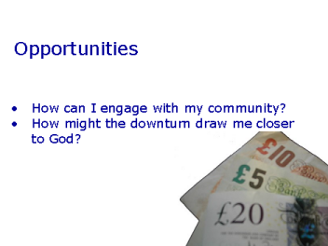 | Slides 10 & 11 : The final two slides pose questions about implications for mission and ministry. Whilst these may apply on a corporate level, they will almost certainly apply on an individual level.  Finish by linking to the leaflet and encouraging church members to use these during the coming week to reflect on the material and apply it to their own faith and finances.

And in doing so, there may be some benefits. I’d like to mention two opportunities.

Firstly, a recession poses implications for ministry, and opportunities for mission. During previous recessions, communities were probably stronger on the whole than they are now. There are lots of ways that we can engage with others - to bless them by an act of kindness, to help them out in some small practical way, so that as we work within the community, relationships are strengthened. Communities are transformed not by some great vision, construction project or major initiative, but by individuals who want their community to be a community. One of the great strengths of being the Church of England is that for us there is no part of the country that is not cared for by the C of E. The challenge for us is “do we love our neighbour as ourselves” - are there ways that we are willing to be used by God to transform this community - day by day, encounter by encounter, person by person.

And finally, in encouraging you to consider how we might take a Christian view of living in a recession, can I draw your attention to the leaflet that accompanies today’s talk. This offers seven reflections - you might want to work through these daily over the coming week.

A billion isn’t what it used to be, but God is the same yesterday, today and forever. He is faithful and has a love and care for each one of us. It is quite possible that a financial downturn may help draw us closer to God both individually and as a nation. Certainly some churches have seen an increase in the number of people calling in for quiet reflection and prayer. It’s often the case that people draw near to God when times are challenging and there is sadness in their lives, than when times are good and everything is going well. Possessions, money and happiness can shield us from our need for God. Whilst none of us want to go through hardship and difficult times, there can be good things that emerge from them.

