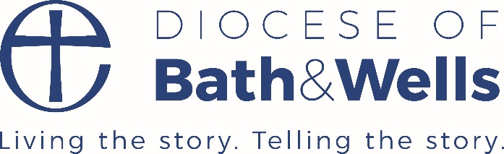
Good practice in SIAMS self-evaluation
‘Vision Provision, Impact’
How effective is the school’s distinctive Christian vision, established and promoted by leadership at all levels, in enabling pupils and adults to flourish?’
Some tips to help with SIAMS self-evaluation:
- Keep the inspection question in mind
- Try to keep the CEEO SEF (or other self-evaluation document) ongoing and reviewed at regular intervals – record date of review and any agreed actions
- Perhaps review at termly Ethos Committee meetings, then report to the FGB for comment and input – perhaps focus on one or two strands each time
- Self-evaluation is for everyone, although one person might collate
- Remember, it’s about Action taken and Impact of those actions
- Refer to the Grade Descriptors in the Evaluation Schedule – perhaps use the language in each strand that describes a good church school
- Gather and keep evidence for the seven strands – perhaps store in a box or file or portfolios
- What counts as evidence?
- RE planning and children’s work, Collective Worship plans and evaluation, letters from parents, parental questionnaires, photos of events, displays or spiritual areas inside and out, governor minutes, governor visit notes, notes from SIAMS reviews, relevant Ofsted comments etc. information on withdrawals from RE and Collective Worship
- Your website is crucial – make sure your school’s vision and values are really clear and relevant policies are there - include Collective Worship and RE policies, and parents’ right of withdrawal
- Keep the website up to date with recent evidence of how you are living out your Christian vision and foundation
- Check the school is adhering to the RE Statement of Entitlement and the new Collective Worship Statement (good idea to make reference to them)
- Above all, try to demonstrate, through the seven strands, how your school’s Christian vision runs though the life of the school, like a golden thread.
- Remember the inspector will ask for a 2–3-page summary of your ongoing self-evaluation
You will have lots more ideas and examples of good practice. Please do send them to us by email, so we can share with others.
N.B Going forward, it may not be evident when, within an academic year, your SIAMS inspection will happen, so we are really keen to give as much support as possible, so you can feel confident to welcome the inspector at any time.
Pauline Dodds April 2021

