New Housing Conference Key Speakers

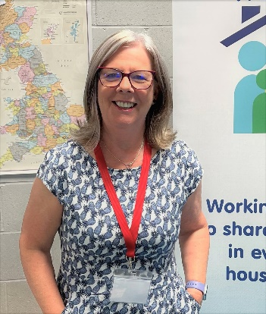
Penny Marsh chairs the Churches Together in England New Housing Areas group and is a co-director of the New Housing Hub. She is also a member of the Ebbsfleet Development Corporation Planning Committee, and a board member of the Ebbsfleet Garden City Trust.
Penny is a Baptist Minister. Along with her family, Penny has been pioneering in new housing areas since her ordination 25 years ago. Currently Penny is a mission enabler for the South Eastern Baptist Association, with a specific focus on pioneering in the new Ebbsfleet Garden City in Kent.
As a pioneer, Penny has experienced both incarnational living and ‘being a guest’. As Ebbsfleet will be a new town with 15,000 new homes, much of the preparation has involved working with other denominations, council and planners.
Penny loves the opportunities and challenges that new housing developments present and is keen to see missional communities emerge that witness to the love and transformational power of Christ.

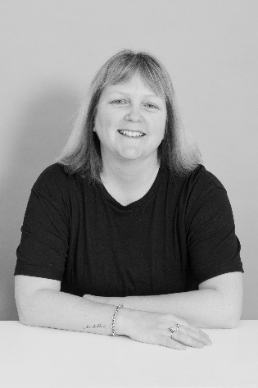
Fiona Mayne is an ordained pioneer minister who leads a church on a new housing estate in Haywood Village Weston Super Mare.
Formerly working as an Independent Financial adviser for 20 years she came to know God personally for the first time in 2012. She was so overwhelmed by the experience that she went on to tell the good news to everyone she met!
She started a pop up cafe in September 2016 on the new housing estate through her sending church and from that started Haywood Village Church in 2017. This meets weekly round a meal in the school community kitchen and monthly in a bigger setting in the school hall over tea and toast. Haywood Village Church is now its own church separate from the sending church

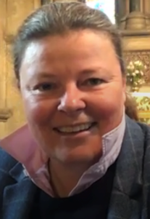
Sarah Bagnall is churchwarden for the Parish of Gilston & Eastwick where their two church buildings will shortly find themselves at the heart of a development of 10,000 new homes.
As a resident, mission enabler and Christian, Sarah has worn a number of hats as the parish have engaged with planners, developers, the local councils, and agencies to ensure that the churches can be a hub for the new communities and a welcoming presence that is fit for the future.

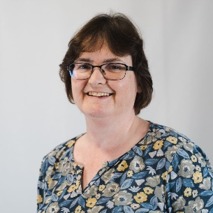
Emma Critchley is the Pastoral and Advisory Secretary for St. Albans Diocese. She has shaped the St Albans response to large-scale housing developments over the past 9 years through the specialist work of the Development Plans Monitoring Group, seeking an appropriate missional strategy for each site, identifying the resources that will be needed and promoting planning at diocesan and deanery levels.
Emma has drawn together two successful parish workshops on housing and new communities and has encouraged and supported the St Albans New Housing Hub which emerged from the more recent workshop.

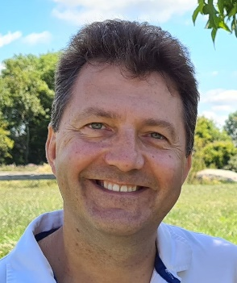
Tom Yacomeni has worked in Parish ministry for over 20 years with an emphasis on Church growth and planting.
Tom was ordained as a Pioneer minister and has led church planting and revitalisation teams in Weston-super-Mare. He has also served as Area Dean of Locking with a strategic focus on pastoral reorganisation to enable growth. In September 2022 he moved to Bath to serve as Rector of All Saints Weston with North Stoke and Langridge. Tom has a passion for encouraging new leadership and helping everyone find their niche role in God’s Kingdom.

