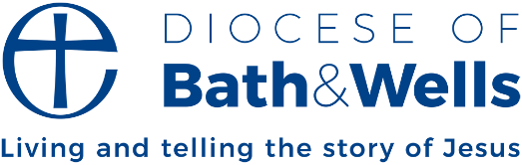

Generosity begets generosity
By Michael Beasley, Bishop of Bath and Wells
In August I was privileged to dedicate the restored clock in the tower of Montacute church. It’s not just any old clock. In fact, Montacute’s is amongst the oldest in the country. Built in the village in around 1400, the clock is so old that it is held in place by iron wedges. At the time of its construction, the nut and the bolt wouldn’t be invented for another hundred years!
The Montacute clock is an artefact that seems to generate generosity. In the 1980s the clock was restored by Humphrey Hamlin, for whom it is now named. Humphrey poured time and energy into its mechanism, preventing it from being scrapped. During the last two years, heroic efforts by the people of Montacute have led to its further restoration. All this was marked last month by a whole village gathering. The community choir sang, morris men danced, the local pub provided a hog roast, cake was dispended in huge quantities.
Montacute’s is a beautiful example of how generosity begets generosity. Like a chain reaction, one act of generosity, the restoration of the clock, led to another, another and another. As a result, a whole community was brought together in celebration and joy.
In his second letter to the Church in Corinth, Paul writes of the church in Macedonia that ‘their abundant joy and their extreme poverty have overflowed in a wealth of generosity’ (2 Cor 8:2). Having nothing, the Macedonians discovered that they could still give. In turn, their generosity enabled Paul to challenge and encourage the church in Corinth to do the same. All to help the struggling Church in Jerusalem.
As I travel around our diocese, I see this pattern of generosity begetting generosity happening in so many places. One person starts, another adds their contribution, more join in and soon we learn that together we are so much more than the sum of our parts. This is the economy of God. It’s an economy that all of us are invited to join.
Bishop Michael

