Safeguarding Newsletter – August 2023

I hope you have all had an enjoyable summer. I have returned from a lovely family break on the Island of Gozo. (Malta) I did have to pretend it was a working holiday as we enjoyed the fantastic week-long feast and celebration of the Assumption of Mary in a country that passionately and proudly lives and celebrates its faith. We had a week of marches carrying giant relics, brass bands, fireworks, and bell ringing. I thoroughly enjoyed the carnival atmosphere – once I was assured their safeguarding was in place of course! It was impossible not to feel more connected and grounded after this experience and my children are enthusiastically going to see if a week-long festival can be adopted by their church and local council.

Sadly, I caught Covid on the flight home so I’m currently working from home, so I do apologise if I’m slower to respond than normal.

Parish Safeguarding Officer wellbeing.
The role of a PSO can be exceptionally challenging as well as rewarding. We recognise that for many people stepping into this role on a voluntary basis can find it time consuming and emotionally difficult. I often find it the hardest when dealing with a concern that resonates with something I have experienced within my own life. I wanted to assure you that if you find the role tough at any time, we are here to support you. This may be through providing you with space for a debrief, an informal chat over a cup of coffee or, if needed, access to counselling. Please know that you can contact myself or a member of my team for support and a non-judgemental sympathetic ear. The most rewarding part of what we do is supporting you.
Safeguarding Sunday – 19 November 2023
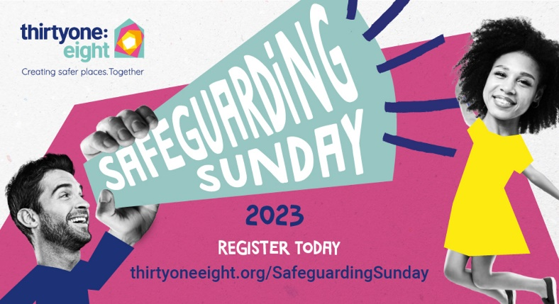
It is almost that time of year again folks. After a very successful event in 2022 we are looking to do even better this year. It really is a chance to celebrate all that your parish does to protect children and vulnerable adults. To register click the following link. Safeguarding Sunday | Thirtyone:eight (thirtyoneeight.org) I’m also asking for volunteers who can promote the event on your websites and social media streams. Perhaps you could include a short video, or photo of your church, alongside a description of what it is to be a part of a faithful and safe church community. Find out more about how you can get involved on our diocesan website: https://www.bathandwells.org.uk/safeguarding-sunday-2023.php

New Provider for DBS checks
A reminder that we are shortly moving to a new DBS provider, thiryone:eight, and there will be some new processes to adopt. You should all now have received an email with registration documents from Leonie and I ask that you return these as quickly as possible so that we can set you up from the off. If you have not received these please email DBS.Safeguarding@bathwells.anglican.org. The plan as it currently stands is to turn off the capacity to start new DBS applications on the Capita system from the start of October but we will keep the account live until all results are returned. Please see July’s newsletter for more information about why we are undertaking this change and rest assured it is to reduce the burden on our PSOs.

Training
Please note dates are now live for registering for Leadership Training in September and beyond. We will also be running a chaplaincy safeguarding event later this year and a spiritual direction safeguarding event in the new year.

The Safeguarding team will also be attending the Churchwarden Days in July and September. You can see all our safeguarding training dates on the diocesan events calendar, just select safeguarding from the drop-down menu.

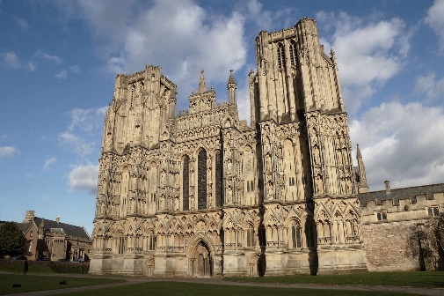
Wells Cathedral
Did you know the diocesan Safeguarding team also provides safeguarding services to Wells Cathedral? If you also volunteer, there and have a safeguarding concern please contact Jo or myself. Jo works from Wells Cathedral one day a week.

Out of hours cover
Another reminder that The Diocese of Bath & Wells partners with thirtyone:eight in relation to accessing the safeguarding Helpline on 0303 003 1111 during out of hours (It operates 5pm - midnight on Mon-Fri; 7am - midnight on Sat and Sun), on bank holidays and other absences. This service is being chronically under used in comparison to the high volume of out of hours calls I used to receive. I want to reassure you that thirtyone:eight are a Christian safeguarding organisation and work closely with many dioceses. They offer the same advice that we would give and should be your first point of contact out of hours.

Parish Safeguarding Officer Forum
Our next forum will be on Wednesday, 11 October at 4pm. (details will be provided nearer the time)

Safeguarding posters
We have a number of safeguarding posters and dashboard leaflets left over from the last Clergy Day. If you would like one, please drop into the safeguarding office in Flourish House.

With warm wishes
Ben
Ben Goodhind
Diocesan Safeguarding Manager
Diocese of Bath and Wells

Diocese of Bath and Wells – Safeguarding team
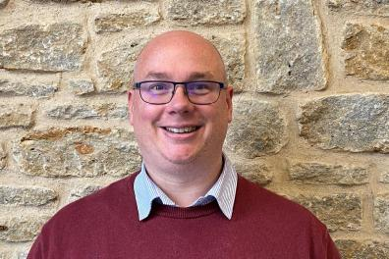 |  | 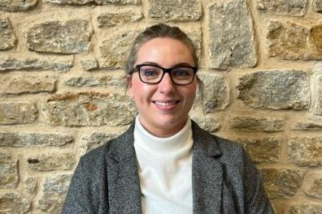
Ben Goodhind, Safeguarding Manager  01749 588917  Ben.Goodhind@bathwells.anglican.org |  | Jo Austin, Safeguarding Caseworker  01749 588905  Joanne.Austin@bathwells.anglican.org
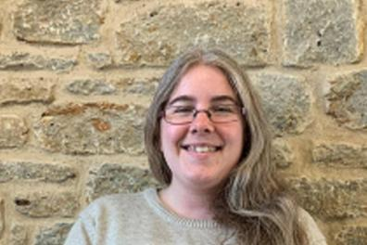
Leonie Jones, Safeguarding Coordinator
01749 588907
Leonie.Jones2@bathwells.anglican.org

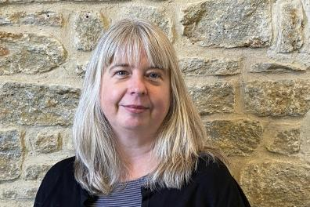 |  | 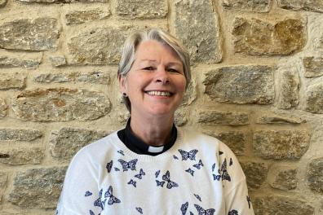
Enita Andrews, Safeguarding Trainer  training.safeguarding@bathwells.anglican.org |  | Jacqueline Keir-Bucknall, Safeguarding Trainer  training.safeguarding@bathwells.anglican.org

