Safeguarding Newsletter – May 2023
I hope May’s newsletter finds you well and enjoying some warmer weather. Being allergic to literally everything that flowers this time of year comes with some challenges for me, but I do enjoy the optimism that Spring provides.

How do we know parishes are safeguarding effectively?
One of the questions to came out of the recent Bishop’s Council meeting was that “whilst people can see the active changes being delivered by the diocese, safeguarding happens at ground level so how can we be assured parishes are doing this well?”.
In 2024 we are going to be audited from a safeguarding perspective in Bath and Wells so this is a very pertinent question. Whilst we can use data tools on the dashboard to see what parishes are undertaking tasks correctly, it is important to get a feeling for how churches feel more widely. Do Congregants feel safe in church? Do they believe their concerns would be acted on? Do people know how to report safeguarding concerns?
I’m really interested in any ideas you have about how we can get a broad feel for how things are going. Would an online survey work? How would we promote it? When is the best time of year to do it?

Out of Hours cover
Another reminder that The Diocese of Bath & Wells partners with thirtyone:eight in relation to accessing the safeguarding Helpline on 0303 003 1111 during out of hours (which operates 5pm - midnight on Mon-Fri; 7am - midnight on Sat and Sun), on bank holidays and other absences. This service is being chronically under used in comparison to the high volume of out of hours calls I used to receive. thirtyone:eight are a Christian safeguarding organisation and work closely with many dioceses. They offer the same advice that we would give and should be your first point of contact out of hours.

Parish Safeguarding Officer Forum
Our next forum will be on Wednesday, 19 July at 3.30pm. A link will be provided in June’s newsletter.
Safeguarding Posters
A number of churches are still promoting outdated details for the Safeguarding team in their premises. Please can you check your posters have my name and my landline on them. New posters can be downloaded from the Safeguarding Resources and Policies page of the diocesan website.

Celebration of Lay Ministry
Each year we come together to celebrate all the gifts people share in their communities, churches and contexts. This year the Celebration of Lay Ministries takes place on Saturday 15 July from 1pm, St. James’ Church, Taunton.
This is a great opportunity to share in the successes of the last year and be recognised for the hard work you do as Parish Safeguarding Officers. For more information and bookings visit the Celebration of Lay Ministries page on the diocesan website.
New Leadership Training from September
For those of you requiring leadership training you will notice a significant change to the course material from Autumn. Whilst existing training remains valid these courses are always evaluated and renewed over time, which is important to keep it fresh, up to date and responding to feedback. My advice is that if you are yet to undertake Leadership training do complete it prior to the summer break and then use the new course for your refresher in three years. Further information will be made available ahead of its launch in September. Please note dates are now open until the summer break at the end of July. We are unlikely to offer training in August as our trainers prepare for our new course.
Safeguarding in the news
You may be aware that Safeguarding in the Church of England has been in the news following the publication of the review of the Trevor Devamanikkam.
The review, which you can find on the Church of England website, was commissioned by the National Safeguarding Team, NST, and carried out by Jane Humphreys, a Senior Social Care Consultant, and previous Director of Children’s and Adult’s Services with a career spanning more than 30 years.
She makes a number of recommendations for the Church including about lessons learnt reviews and responding well to survivors; as well as the need for clear guidance to all clergy and Church officers as to what they should do and who they should take advice from if copied into an allegation of abuse.
While it has been reported that the former Archbishop of York, Lord Sentamu has rejected the findings of the report, Jane Humphreys has stated, "no Church law excuses the responsibility of individuals not to act on matters of a safeguarding nature".
The current Archbishop of York, Stephen Cottrell, has also welcomed the report and has given his commitment that the Church of England will learn from the recommendations to ensure the Church is a safer place for all.
“I would like to echo Bishop Joanne’s response and have made personal contact with the survivor. While safeguarding in the Church has improved enormously in the past 10 years, we can never be complacent and today’s report is a reminder that we still need to learn from how to respond well to those who come forward always being mindful that the effects of abuse are lifelong.”

What areas do our Diocesan Safeguarding Teams cover? What is faith-based safeguarding?
There is some confusion around what constitutes a safeguarding case for church purposes, as the definition of vulnerability the church uses is different to the statutory definition. To further complicate matters the term safeguarding as applied by safeguarding teams is narrower than the everyday concept, which could include wellbeing.
The diocesan Safeguarding team will manage allegations against Church Officers where the victim meets one of the vulnerability criteria below or where the allegation is one of the specific cases listed below.
If the respondent is not a Church Officer, the Safeguarding Team will provide advice and support but not take responsibility for case management.
Safeguarding Vulnerability Definitions
Children
All children under 18 are considered to be vulnerable. Any allegation of abuse or neglect of a child should be referred to the Safeguarding team.
Adults
1.Care Act
Statutory Guidance issued under the Care Act 2014 (14.2) by the Department of Health uses the term ‘adults experiencing, or at risk of abuse or neglect’ to assess eligibility to statutory social care services.
(a) has needs for care and support (whether or not the authority is meeting any of those needs),
(b) is experiencing, or is at risk of, abuse or neglect, and
(c) as a result of those needs is unable to protect himself or herself against the abuse or neglect or the risk of it.
Any allegation of abuse or neglect of an “adult at risk” should be referred to the Safeguarding Team.
2. Church
For the purpose of Church policy and guidance the definition of ‘vulnerable adult’ is contained in the Safeguarding and Clergy Discipline Measure 2016, which defines a ‘vulnerable adult’ as ‘a person aged 18 or over whose ability to protect himself or herself from violence, abuse, neglect or exploitation is significantly impaired through physical or mental disability or illness, old age, emotional fragility or distress, or otherwise; and for that purpose, the reference to being impaired is to being temporarily or indefinitely impaired’.
In cases where the adult is not “at risk” under the statutory definition but maybe considered “vulnerable” under the church definition it will be necessary to assess whether their ability to protect themselves is “significantly impaired”.

Specific allegations
Safeguarding Team will manage allegations against Church Officers where the victim meets one of the vulnerability criteria above or where the allegation is one of the specific cases listed below.
If the respondent is not a Church Officer, the Safeguarding Team will provide advice and support but not take responsibility for case management.
- Sexual Abuse allegations
Require the involvement of the Safeguarding Team, to assist with multi-agency liaison and risk assessment. If the alleged victim meets the vulnerability criteria above then the case could be led by the Safeguarding team but if not, the Safeguarding team should support whoever is managing the allegation e.g. the Archdeacon or HR Manager, but Safeguarding will not lead on the case management.

- Physical Abuse allegations
Require the involvement of the Safeguarding team, to assist with multi-agency liaison and risk assessment. If the alleged victim meets the vulnerability criteria above then the case could be led by the Safeguarding team but if not, the Safeguarding team should support whoever is managing the allegation e.g. the Archdeacon or HR Manager, but Safeguarding will not lead on the case management.

- Psychological Abuse
Psychological abuse involves the regular and deliberate use of a range of words and non-physical actions used with the purpose to manipulate, hurt, weaken or frighten a person mentally and emotionally; and/or distort, confuse or influence a person’s thoughts and actions within their everyday lives, changing their sense of self and harming their wellbeing.

- Domestic Abuse allegations
Require the involvement of the Safeguarding team, to assist with multi-agency liaison and risk assessment.

- Spiritual Abuse
Spiritual Abuse would only fall under the responsibility of the Safeguarding team if the spiritual abuse was a sub-category of other abuse, e.g. psychological abuse, sexual abuse, or domestic abuse. The use of scripture as part of an allegation of verbal bullying would not necessarily require case management by the Safeguarding team. Any isolated concerns of Spiritual Abuse which are no a sub-category of other abuse can be raised with the Archdeacon.

Ben Goodhind
Diocesan Safeguarding Manager
Diocese of Bath and Wells

Diocese of Bath and Wells – Safeguarding team
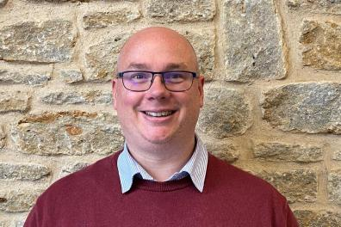 |  | 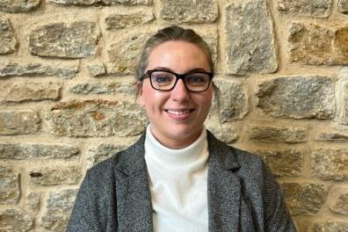
Ben Goodhind, Safeguarding Manager  01749 588917  Ben.Goodhind@bathwells.anglican.org |  | Jo Austin, Safeguarding Caseworker  01749 588905  Joanne.Austin@bathwells.anglican.org
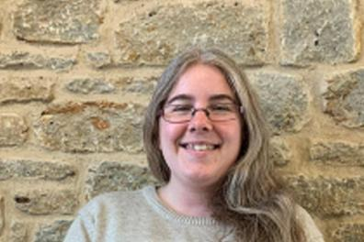
Leonie Jones, Safeguarding Coordinator
01749 588907
Leonie.Jones2@bathwells.anglican.org

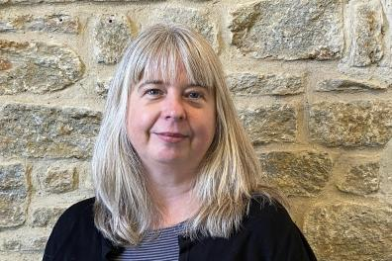 |  | 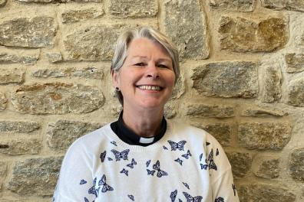
Enita Andrews, Safeguarding Trainer  training.safeguarding@bathwells.anglican.org |  | Jacqueline Keir-Bucknall, Safeguarding Trainer  training.safeguarding@bathwells.anglican.org

