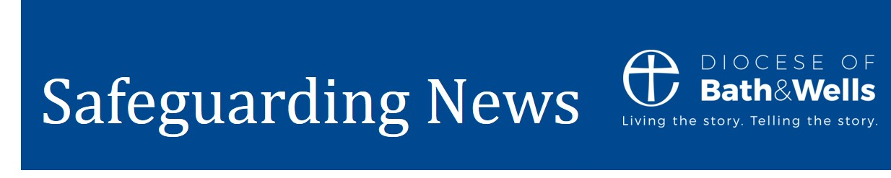

May 2022

Team news

Just a brief update this month for you all. We are continuing to develop our team in order to provide yourselves and the diocese with an improved service. This involves moving to a set up where responses and support are quicker and more effective. The team has in the past had smaller more niche roles where responses could be slow due to annual leave, a lack of trained staff to cover and part-time hours etc. By using the new mailbox email systems accessible to all staff and training the team to cover each other’s areas of responsibility we will be available to you every working day.

I’m pleased to say we have launched our recruitment for a Full Time Safeguarding Co-Ordinator who will take over responsibility for organising training, advising on DBS and ensuring we have a well-oiled operation. I’m particularly excited to have this role supporting the long awaiting improvements to our website. By the end of the year, you will notice substantial improvements both to the design of it and the content within it. I’m incredibly sorry that our website has not been fit for purpose and appreciate the impact of this on all of you. This new role will replace the two separate roles undertaken by Helen and Sam who have recently departed. When we are able to announce the new recruit I hope to provide this update via an interview on the diocesan website and social media channels.

DBS Checks
The anticipated delays to DBS checks have thankfully not occurred. We have managed Helen’s departure well and have found ways to make the process much faster. This has been achieved by setting up a dedicated DBS mailbox and training up several staff including myself to be able to access the system. Previously only one person was able to complete this process and being part time, this often led to delays especially with annual leave. We do have some further improvements in the pipeline which will be shared as soon as possible.

Please do email the dbs.safeguarding@bathwells.anglican.org address rather than individual staff for DBS queries to get the swiftest response.

Training

Our training courses are all filling up exceptionally well. So well in fact that we are now fully booked until the middle of June for our Leadership courses. Our apologies for the delay in updating the website to illustrate this, but it has now been updated for you to show available courses until the end of the summer. If you have a question about the training content, please do contact Cameron our trainer. Cameron has been on a fantastic holiday but is due back next week. Cameron.Mcconnell@bathwells.anglican.org

Interested in organising a training event in your Parish, Benefice or Deanery or want to discuss creating some bespoke training? Do email ben.goodhind@bathwells.anglican.org

For training bookings please email: training.safeguarding@bathwells.anglican.org

Are you a new PSO or a PSO want the induction you never had?

We have a new Parish Safeguarding Officer (PSO) Induction training course and there is one taking place from 2pm to 5pm at Flourish House. There are spaces on this course which will be a great opportunity for you to network with other people in role. This will give you a chance to meet Ben and the team and go away feeling more confident both in your role and the support that will be offered to you.

Find out more about the course on the Safeguarding Training web page.
To book please email: training.safeguarding@bathwells.anglican.org

PSO Forum.
Our inaugural PSO forum will take place at 15:30 to 17:00 on 15 June on Microsoft Teams. Please do let us know if you wish to take part. In future these will be held quarterly just before our Diocesan Safeguarding Panels. This is a chance to come and ask any questions, listen to any updates, and share good practice and experiences. This is not in any way compulsory more an offer to try and provide more support and gain feedback on how we can work more effectively or on what is working well.

Best wishes

Ben Goodhind
Safeguarding Manager
Diocese of Bath and Wells

