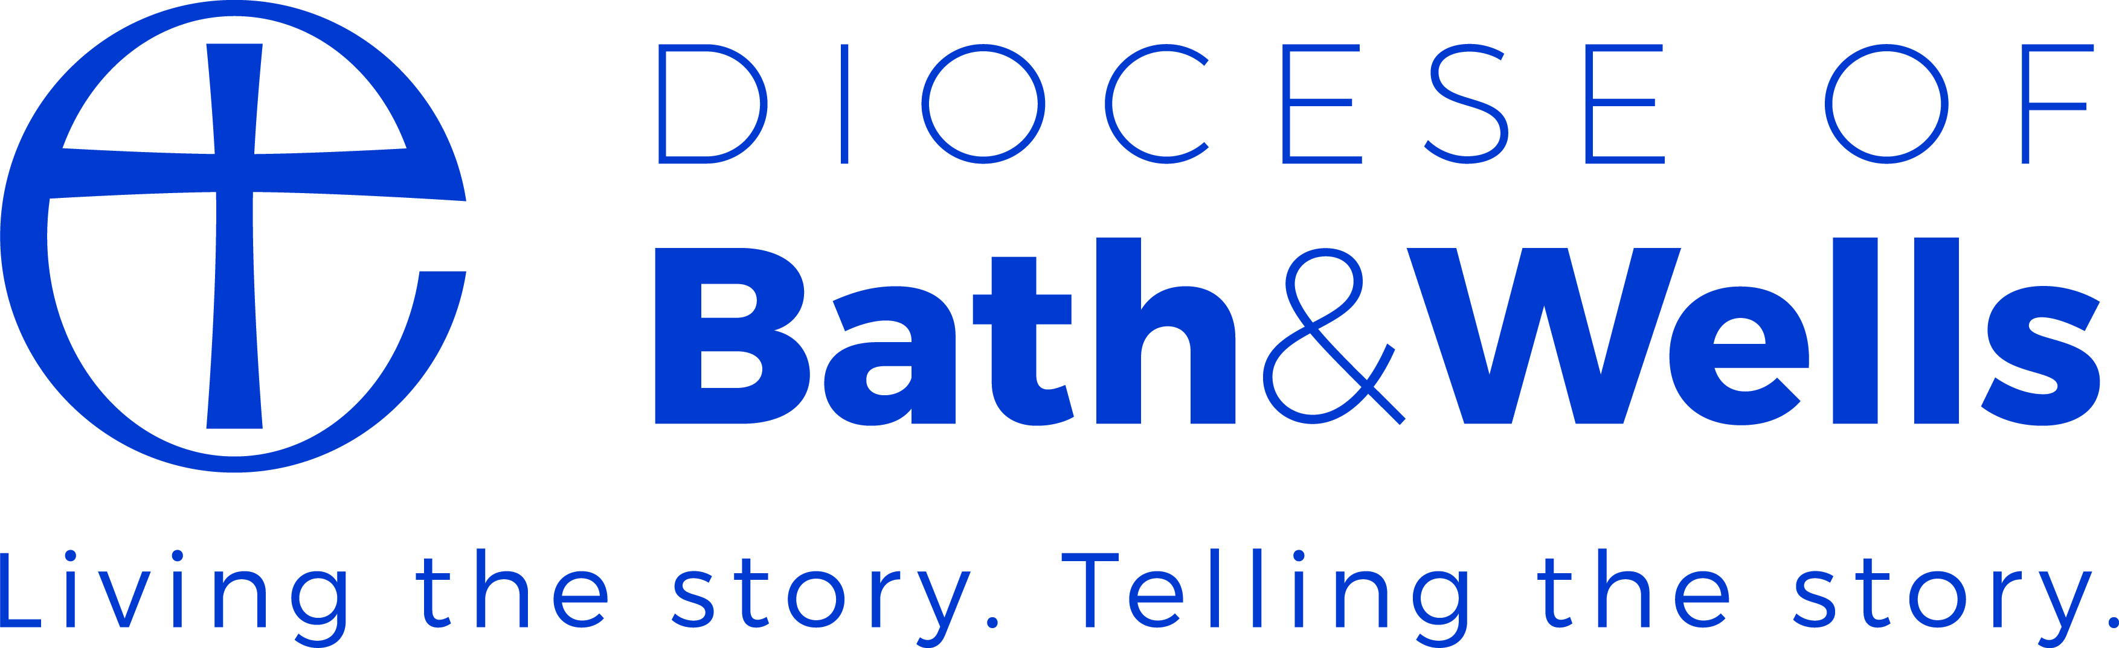

Module / Theme : Relationships
Activity : Develop a Partnership Agreement together

Purpose :
This activity is designed to give you a format to consider in helping you to draw up a partnership agreement together.
Resource : Model Church and Church School Partnership Agreement – Diocese of Liverpool

How to use this activity
- Read through the partnership agreement together
- Consider whether this might be a helpful approach in your context
- Consider who might be involved in putting together the partnership agreement and what you would do with it.
- Evaluate the content and format of this particular partnership agreement
- Begin to draft your own partnership agreement

