

**Module/Theme:** Relationships

**Activity:** Church/Church School Team Building - holding an Away Day

**Key link:** Bath & Wells diocesan strapline: ‘Living the story, telling the story’

**Purpose:**

It may be possible from time to time for schools to use an INSET day as an opportunity to partner with their parish at a venue away from school and in or out of the parish. This could contribute to the well-being of all, could be an opportunity to consider the school’s vision and values, for team building at the beginning of the new academic year or for clergy and leaders of schools in a newly-formed Multi-Academy Trust. Below is a list of venues in different parts of the Diocese that might be suitable and not too pricey!

**Venues to book:**

[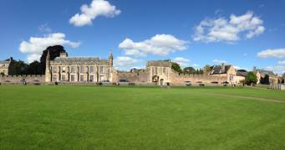](http://www.bing.com/images/search?q=old+deanery+wells&id=0744C3AEBDDF5FABBE9DC04F78E0F11905DC109F&FORM=IQFRBA)

The Old Deanery, Wells

E: [reception@bathwells.anglican.org](mailto:reception@bathwells.anglican.org)

Tel: 01749 670777

[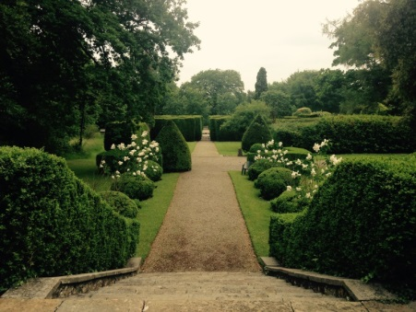](http://www.ammerdown.org/public_scripts/resizer.php?file=../domains/ammerdown.org/local/media/images/medium/Back_Garden__8_.jpg&preset=fullscreen)

**The Ammerdown Centre**, **Ammerdown** Park, **Radstock**, Somerset, BA3 5SW

E: [centre@ammerdown**.**org](mailto:centre@ammerdown.org)

Tel: 01761 433709

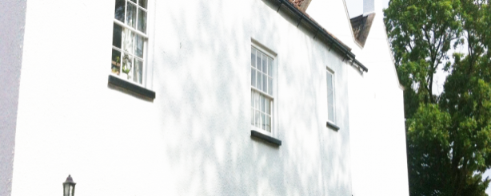

Trinity House, Nailsea,Holy Trinity Church, 2 Church Lane, Nailsea, BS48 4NG

E: [welcome@htnailsea.org.uk](mailto:welcome@htnailsea.org.uk)

Tel: 01275 853227

[](http://www.bing.com/images/search?view=detailV2&ccid=kFh4AkOn&id=81D8DFC37D3E6CFC567697E8508FF35758EA09DB&q=glastonbury+abbey&simid=608038491441663021&selectedIndex=0)

Glastonbury Abbey, Abbey Gatehouse, Magdalene Street, Glastonbury, BA6 9EL  
E: [info@glastonburyabbey.com](mailto:info@glastonburyabbey.com)

Tel: 01458 832267

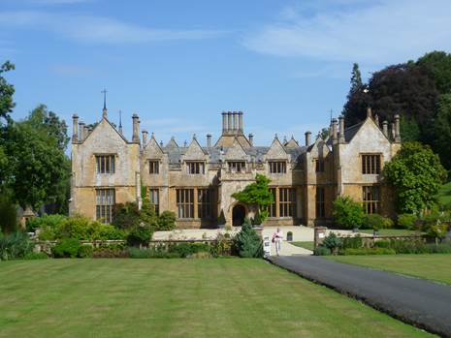

Dillington House**,**  [Ilminster TA19 9DT](http://www.bing.com/local?lid=YN1100x260760530&id=YN1100x260760530&q=Dillington+House&name=Dillington+House&cp=50.9359664916992%7e-2.90127229690552&ppois=50.9359664916992_-2.90127229690552_Dillington+House&FORM=SNAPST)

E: dillington@somerset.gov.uk

Tel: 01460 258648

[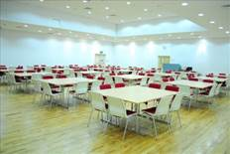](https://en.wikipedia.org/wiki/File:Bridgwater_Canalside_Centre.jpg)

The Canalside , Marsh Lane, Bridgwater, Somerset, TA6 6LQ

E: info@thecanalside.co.uk  
Tel: 01278 456545

[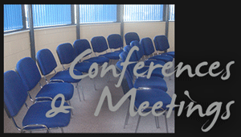](http://junction24ltd.co.uk/conferences-meetings/)

J24, Sedgemoor Auction Centre, Market Way, Bridgwater, TA6 6DF E: [enquiries@junction24ltd.co.uk](mailto:enquiries@junction24ltd.co.uk)

Tel: 01278 662200

or………..why not try an overnight retreat at Ammerdown, a spa session , or a visit to a local place of interest..