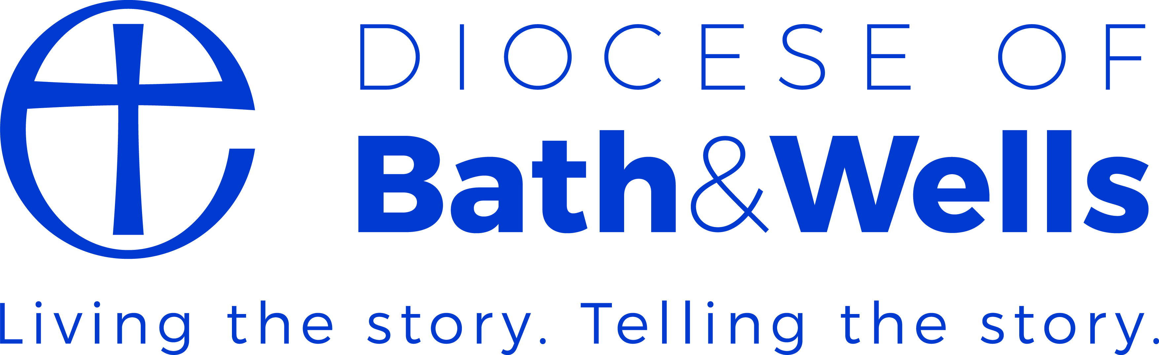

SIAMS 2018: A brief guide for Governors
The Inspection Question:
‘How effective is the school’s distinctive Christian vision, established and promoted by leadership at all levels, in enabling pupil and adults to flourish?’
Vision
A key change in the inspection framework is the emphasis on Christian vision. Each school’s vision should be unique to each school, reflecting the area it serves.
Implicit in the SIAMS are the questions: Who are we? & Why are we here? Governors may find it useful to ask themselves:-
- Who are you as a school?
- Why are you here?
- What is special or particular about your school?
- What is your school’s vision

Nevertheless the central principles of the Church of England’s Vision should be common to all schools (and these are now reflected in four of the seven strands of the inspection schedule)

Educating for Wisdom Educating for
Knowledge and Skills Hope and Aspiration

‘Life in all its fullness’ (John 10:10)

Educating for Community Educating for
and Living Together Dignity & Respect

See: Deeply Christian – Serving the Common Good: the Church of England’s Vision for Education

What SIAMS is looking for in a school’s vision:
- Commitment to an excellent education
- Desire for every individual to be the best person they were created to be (aspiration)
- A concern for the collective good of all in the school community and beyond (hope)
- Pupils must learn how to live well together in society
- The importance of all in the school treating each other with respect

However the vision is not simply a cosmetic exercise. It should underpin everything else in the school. Within the Christian vision section, it’s important to highlight the accompanying theology clearly as well as the resulting story / action. This can then be illustrated by the values, strapline and logo.
Policies
The following policies should flow from the Christian vision and show how the vision is implemented within school life. They should be included in the normal policy cycle of governors and accessible from the website (warning – Inspectors look at the website well before the inspection).

Anti-bullying | Mental health and wellbeing
Behaviour | Relationships and sex education
Collective worship | Religious Education
Equality & inclusion | Social, moral, spiritual and cultural education
Admissions (VA only)

School self-evaluation
There are three key questions for governors when looking at self-evaluation:-
Vision: What is your Christian vision for the school?
Provision: What do you do because of your Christian vision?
Impact: How do you know it is working?

Strand 1: Vision and leadership | A clear theology / Christian narrative  Operational partnerships  Preparing new church school leaders  Role of governors/ academy directors
Strand 2: Impact of the school’s Christian vision on wisdom, knowledge and skills | Standards (esp. vulnerable groups)  Spiritual development e.g. ‘Windows, Mirrors, Doors’  Curriculum decisions
Strand 3: Impact of the school’s Christian vision on hope and aspiration | Character education  Courageous advocacy e.g. challenging disadvantage & deprivation  Social action and charity work
Strand 4: Impact of the school’s Christian vision on community and living well together | Forgiveness & reconciliation  Inclusion, behaviour & exclusion  Mental health and well-being  Learning to disagree well  Community and church links  Global partnerships and interfaith dialogue
Strand 5: Impact of the school’s Christian vision on dignity & respect | Celebrating difference and diversity  Anti-bullying  Relationships & Sex education
Strand 6: Impact of Collective Worship | Inclusive, inspirational and inspiring  Central to the life of the school
Strand 7: Quality of religious education | Reflects RE ‘Statement of Entitlement’  Clear aims & purposes  Approach & organising principles  Leadership & management  Assessment  Effectiveness of teaching & learning (VA only)

Questions for Governors:
- When did you last reflect on the ‘Who are we?’ questions (above) as a Governing Body?
- Does your vision statement reflect the four key points in the church’s vision?
- Is your vision supported by a clear Christian narrative?
- Does your vision (incl. theology) undergird your values, policies, strapline and logo?
- Are your key school policies (above) up-to-date and accessible through the website?
- How do you know about the school’s provision and the impact of that provision?

Action points for your school:

