Multi-Cultural Britain – a workshop for KS2 led by Gloria Lawrence
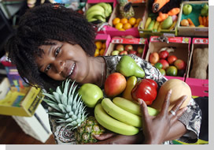
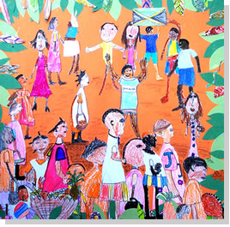

This workshop aims to give children across the KS2 age range an understanding of how people from minority ethnic groups came to this country and settled. Gloria will use the experiences of herself and her family as a starting point. Through this approach children will gain insights into the personal experiences of people who migrated to Britain, their hopes and motivations, developing a foundation for positive responses to diversity. With Gloria’s vibrant story telling skills, and accompanying music provided by Roger Cawsey, the workshop will provide children with an unforgettable experience.

This workshop will help children to develop their knowledge and understanding of the diverse nature of British society and will tie in with National Curriculum aims such as: 'promote the spiritual, moral, cultural, mental and physical development of pupils’ and ‘prepare pupils at the school for the opportunities, responsibilities and experiences of adult life'.
Some key elements of the workshop
- Starting points - Gloria will introduce herself and give a potted history about why her parents came here, her early memories, her experience of infant and primary school, and how it felt to be 'different'.
- This will be an interactive workshop and Gloria will use photographs, film and music to bring events to life. At each stage there will be a chance for children and staff to ask questions. She will also introduce well known people from minority ethnic groups through the decades up to the present day.
Organisation and costs
The workshop will be flexible and Gloria will work with small or large groups as necessary. The usual cost of this workshop would be £400 per day plus travel expenses but due to local authority part funding the cost to the school will be £200.00 plus travel.

Booking
Schools can contact Gloria direct to discuss workshops and possible dates, Her contact details are: gloriababygiraffe@msn.com 07837 877456

Learning Outcomes

1. Children know some of the reasons why Britain has become such a diverse nation since World War 2, based on a knowledge of:

- British history (Empire/Commonwealth)
- Jamaican history(and other countries)
- Push factors
- Pull factors
- Bristol connection

2. Children know about and empathise with some of the difficulties experienced by families moving here:

- Family separation
- Weather
- Racism
- Housing

3. Children know and feel positive about some of the richness that migrant communities have brought to Britain:

- Stories/literature
- History
- Music/carnival/instruments
- Food
- Languages
- Clothes/fashion
- Economy / international trade, eg clothes/food

4. Children know and feel positive about the huge diversity in Britain today and feel linked to the world as a whole:

- Understand that you and lots of other ‘Black/Brown’ people are British
- Realise that you can’t tell from what someone looks like whether they are British or not

5. Children know that moving from place to place and country to country is a common feature of 21st century life:

- Movement within Britain
- Movement between countries (to and from Britain)

