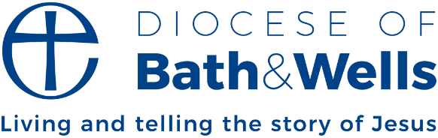

The Prayer for Zambia / Bath & Wells Sunday 2024

Loving God and Father of us all, today we pray for our brothers and sisters in the Zambia Anglican Church.

We give thanks for the 45 years in which we have celebrated life and faith together through our Diocesan Companion Link.

We give thanks for the prayers, for the friendships, for the joys and for the concerns that we have shared.

And we give thanks for all that we have learned from each other as we have sought to live and tell the Good News of Jesus Christ.

We ask for your continuing blessing on us as together we strive to “come to the unity of the faith and of the knowledge of the Son of God, to maturity, to the measure of the full stature of Christ”.

Amen.