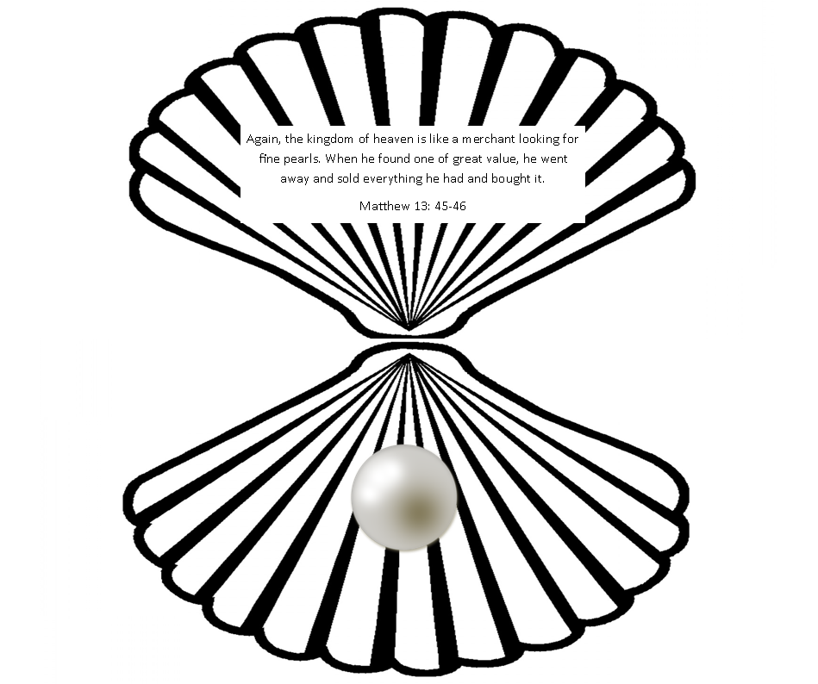

Again, the kingdom of heaven is like a merchant looking for fine pearls. When he found one of great value, he went away and sold everything he had and bought it.

Matthew 13: 45-46