Application Pack July 2020
Young Vocations Ministry Experience Scheme

Young Vocations Ministry Experience Scheme

Application Pack July 2021

Contents

Recruitment Timeline 3
The Diocese of Bath and Wells 4
About the Scheme 5
Job Description 8
Person Specification 10
Main Terms and Conditions 11

Contact details

Human Resources
Ph: 01749 685 113
Email: recruitment@bathwells.anglican.org

Email: Ministry.Experience@bathwells.anglican.org

Dear applicant

Thank you for your interest in the post of Ministry Experience Trainee with the Young Vocations Ministry Experience Scheme with the Bath & Wells Diocesan Board of Finance (DBF). I am delighted to let you have details about the diocese and information about the post.

We hope you find the application pack provides all the information you need in order to consider your candidature for this post. If, however, you have any further questions please initially contact Human Resources. Meanwhile, please find opposite, key dates for the appointment process. Should you decide to apply for this post we look forward to receiving your application and wish you well.

Enita Andrews

HR Manager

Applications
Applications must be received by Friday 16 July 2021. Application forms, with a covering letter no more than one side of A4 describing what attracts you to this role should be returned to Human Resources either by post to:
The Diocesan Office, Flourish House, Cathedral Park, Wells, Somerset, BA5 IFD or by email to recruitment@bathwells.anglican.org.

Shortlisting

To ensure the fairness of the selection process, shortlisting will be based upon the information which you provide in your application and assumptions will not be made about your experience or skills. We will look for demonstrable evidence that you meet the criteria set out in the person specification. Information provided on the application form will be viewed by HR, the recruiting manager and interview panel. A copy of our privacy policy for job applicants can be downloaded from our website.

Interview

Interview will be held on Monday 21 July 2021. Further details regarding the selection process will be communicated at the time applicants are invited for interview.

Safeguarding

We are committed to the safeguarding and protection of all children, young people and adults, and the care and nurture of children within our church communities. We will carefully select, train and support all those with any responsibility within the Church, in line with Safer Recruitment principles. This means that we will:
- Ensure that our recruitment and selection processes are inclusive, fair, consistent and transparent.
- Take all reasonable steps to prevent those who might harm children or adults from taking up, in our churches, positions of respect, responsibility or authority where they are trusted by others.
- Adhere to safer recruitment legislation, guidance and standards.

Further information can be found in our Safeguarding Policy available on the diocesan website. All applicants are required to complete a Confidential Declaration Form as part of our recruitment process when an offer of employment is made. This form is strictly confidential and, except under compulsion of law, will be seen only by those involved in the recruitment/appointment process and, when appropriate, the nominated safeguarding lead or someone acting in a similar role/position. All forms will be kept securely in compliance with the General Data Protection Regulation, 2018.

The Diocese of Bath and Wells
The Diocese of Bath and Wells is one of 41 Church of England dioceses in the country. The diocese stretches from Portishead in the north to Crewkerne in the south, Minehead in the west to Frome in the east.

The diocese loves and serves the 940,000 people who live here through its family of 466 parishes and 181 church schools. This family works for the good of local communities in a range of practical as well as pastoral ways; caring for the vulnerable in our societies, supporting local families and encouraging children and young people.

Everything the diocese does is underpinned by prayer and worship and is driven by our vision:

“In response to God’s immense love for us, we seek to be God’s people, living and telling the story of Jesus.”

If you are called to this role, you will be arriving in the diocese at a time of significant change and you will have a unique role to play in the diocesan strategy, which has these three strategic priorities:

- To place mission and evangelism at the heart of all we do.
- To re-align our ministry resources towards mission.
- To identify, develop, and release the gifts of all our people.
4

About the Scheme
5
The Diocese of Bath and Wells Go Team and Vocations Teams are offering a time limited Ministry Experience Scheme for a trainee (MET) to explore their calling in a ministry context. The Ministry Experience Scheme will work with a deanery, parish or Christian organisation, to provide a placement that will enable the MET to:
  - Gain ministry experience
  - Exercise specific gifts in a ministry context
  - Explore calling alongside the Vocations Team
  - Study and have time to reflect
  - Develop a rhythm of personal devotion and prayer

The ministry experience will include:
  - 10 hours per week in a supervised placement that will provide a variety of work experiences to explore calling. This will include local supervision and meeting with a person for theological reflection
  - 6.5 hours per week spent with a selected training institution to study, reflect and worship in community with other trainees and interns over three eleven week terms.
  - Opportunities to work across the Diocese with regular supervision and support from the one of the diocesan Go Team Advisors.

Over the course of the training:
  - A 24-hour retreat at the beginning of the Scheme;
  - A 2-day leadership conference

There is an expectation of some personal study, writing of assignments and keeping a journal/portfolio, to be completed outside of working time.

Due to the restrictions of external funding the scheme is open to those aged 18 to 30.

Job Description
POST: Young Vocations Ministry Experience Scheme - Ministry Experience Trainee
Our vision
In response to God’s immense love for us, we seek to be God’s people living and telling the
story of Jesus.
Key purpose of the post:
The Diocese of Bath and Wells are offering a time limited paid internship as part of the Ministry Experience Scheme to explore what it means to live out God’s story whilst discerning calling and possible vocation.
Location: Local Placement for study
Reporting to: The Go Team Adviser for the archdeaconry and to the local placement supervisor
Accountable to: The Assistant Director & Go Team Leader and Director of Vocations
Hours of work: An average of 18 hours per week
Key relationships:
The archdeaconry Go Team adviser Assistant Director and Go team Leader Vocations Team Leader
The placement church staff team Young vocations team
Local church leaders, paid workers and volunteers
Other organisations and denominations involved in developing and supporting youth and
children’s ministry

Main Responsibilities:

Location based placement (suggested 10hrs per week):
The local church placement will set up and monitor the local work in each local context and provide local supervision for the work
- Work in a local church placement gaining experience of helping to set up or develop
their ministry and outreach with a special focus on youth / children’s / families ministry.
- Work with the local placement in developing links and mission in the local schools or colleges.
- Have other opportunities in the local placement to explore other gifts and areas of ministry such as teaching, preaching, prayer ministry and pastoral care as part of exploring calling

Personal development and study (6.5 hours per week):
- Participate in a study programme with a local training institution.
There is also an expectation that the person on the Ministry Experience Scheme will develop a daily rhythm of personal prayer, study and devotion. And undertake personal study for the course.

Work with the Go team (suggested 3-6 events across the year to gain diocesan team experience):
- Assist in Go Team with archdeaconry Inspire days as required.
- Assist with Pilgrim days as required.
- Assist with training events as required
Diocesan experience (suggested 3 events across the year to gain experience of diocesan events with peers):
- Assist the Go Team with organising the annual Children’s Festival / youth event.
- Attend the annual half day gathering of paid workers
- Attend the annual chaplains gathering

Accountability and team (suggested 3 hours per month):
- Meet with the local supervisor monthly about work in the placement
- Meet together once a term with the whole Go Team for planning, prayer, study and worship this will include attending an Education Staff meeting and a YCWG meeting once in the year.
- Meet with the spiritual chaplain monthly or as required
- Meet with a vocational mentor termly or as required
- Meet with a theological mentor termly or as required

Other
- Undertake such other duties at the request of the local placement supervisor, Go Team Adviser or Assistant Director as are consistent with the main purpose of the job and its remuneration.

Person Specification

Area | Essential | Desirable
Qualifications, Knowledge and Experience | - A good understanding of Christian ministry in a children/young people context  - Some experience of leading sessions in youth / children’s ministry  - Some experience of how to disciple children/young people  - Awareness of issues facing children/young people and how the church might be able to  engage with these issues | - A good knowledge and understanding of the Bible with some experience in leading Bible based discussions with children/young people  - Some experience of working in a school  - Some understanding of how the Anglican church works and its structures  - A basic knowledge and understanding of safeguarding
Skills, Competencies and Abilities | - Able to work as part of a team  - Able to support and develop volunteers  - Able to juggle a wide variety of tasks and study simultaneously  - Have good organisational skills and some administrative skills  - Have good written and verbal communication skills  - Able to problem-solve | - Able to communicate the Christian faith in vibrant, creative and relevant ways to children/young people  - Able to use Christian resources effectively when working with children/young people
Work Related Personal Qualities | - Be a committed and active Christian who is passionate about sharing the gospel  - Willing to spend time exploring calling into Christian ministry or other forms of vocation  - Have energy, enthusiasm for sharing the Christian faith  - Willing to work flexible and sometimes unsocial hours | - To have an approachable nature  - Have a willingness to learn from others  - Be self-motivated and able to work on own initiative  - Have a valid driving license with primary use of a vehicle

An Occupational Requirement exists for the post-holder is a Christian in accordance with the Equality Act 2010.

The postholder will require an enhanced Disclosure & Barring Service check.

Main Terms and Conditions
9

Hours of Work An average of 18 hours per week, with flexibility in how
hours are distributed throughout the academic year.

Salary £7866 for the duration of the contract.

Term This is a fixed term contract commencing September 2021 until July 2022 (46 weeks)

Pension Pension Scheme administered by the Church of England Pensions Board. The employer will contribute 10% of the employee’s pensionable salary and the employee may
choose to make an additional voluntary contribution of any proportion of their pensionable salary.

Holiday 100 hours including the entitlement for bank holidays.
Holiday may not be taken on designated study days.

Expenses All reasonable working expenses will be met at the agreed
Diocesan rates.

The Diocese will pay expenses for travel to St Paul’s to
attend study days as well as work related expenses for work undertaken under the direction of the Go Team and for any voluntary work undertaken for the Diocese.

Travel expenses for work undertaken with the Placement will be paid by the Placement.

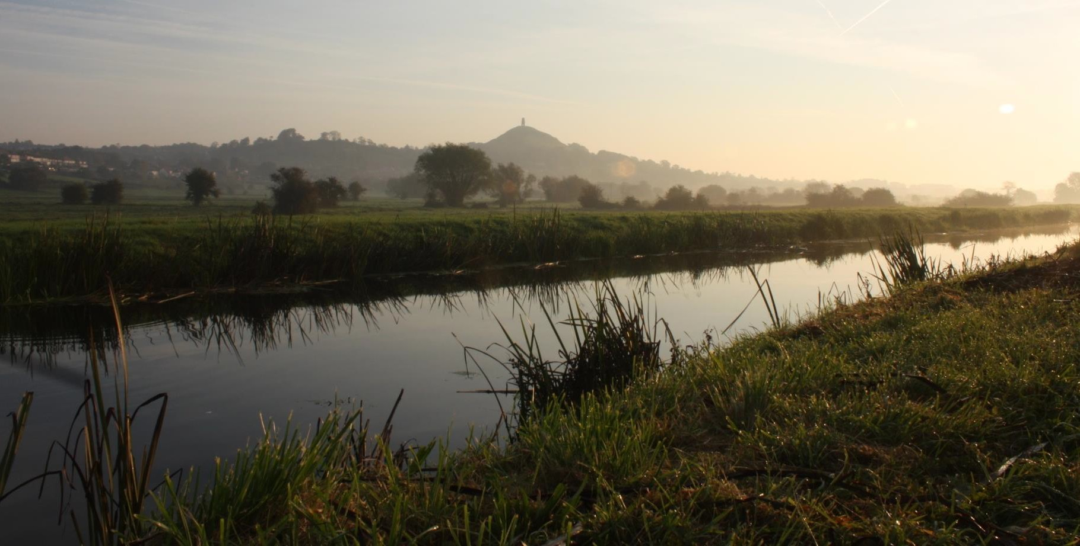
Probation This post will be subject to a probationary period.

