

**Yr6 Pilgrim Days June 2021**

**Service Booklet**

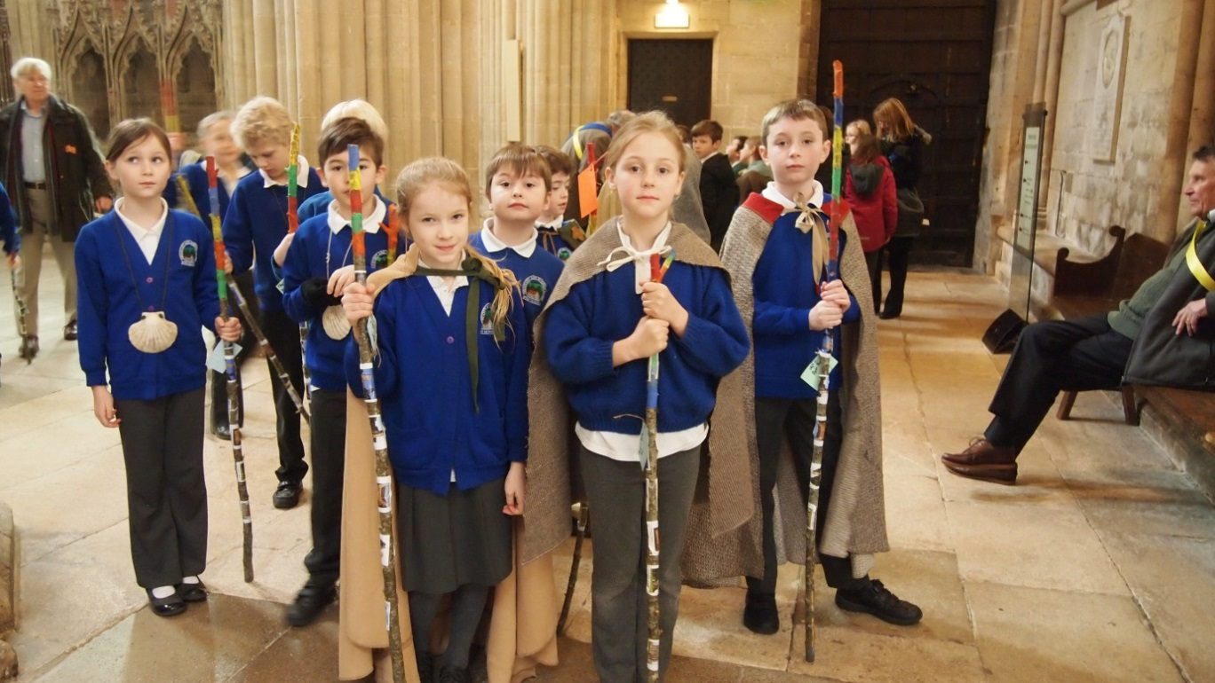

**We discover God**

**not at the end of our pilgrimage**

**but in the pilgrimage itself.**

**A step along the world I go.**

**A step from old things to new.**

**God, on my pilgrimage through life**

**keep me travelling along with you..**

**‘That they may have life, life in all its fullness’ John 10:10**

All hymns covered by Christian Copyright Licensing (Europe) Ltd CCL No. 1065191 or Calamus Licence No. 3048.

**OPENING WORSHIP**

**The Welcome**

God is good

**All the time**

All the time

**God is good**

**The Pilgrim’s Greeting**

Why have we come together to this special and sacred space?

**We are Pilgrims.**

**We are on a journey,**

**travelling to meet the God of the past;**

**to meet the God of the present,**

**to meet the God of our future.**

What will you do here?

**Together we will discover things about this pilgrimage, ourselves and God.**

What will you find here?

Together we will find fun, enjoyment and peace.

What will you take from here?

We will take all we have learned back to our schools, our homes and our families.

**Now we will sing together**

Colours of day dawn into the mind,

The sun has come up, the night is behind.

Go down in the city, into the street,

And let’s give the message to the people we meet.

Chorus So light up the fire and let the flame burn,

Open the door, let Jesus return.

Take seeds of his spirit, let the fruit grow,

Tell the people of Jesus, let his love show.

Go through the park, on into the town;

The sun still shines on, it never goes down.

The light of the world is risen again;

The people of darkness are needing our friend.

Chorus

Open your eyes, look into the sky,

The darkness has come, the sun came to die.

The evening draws on, the sun disappears,

But Jesus is living, his Spirit is near.

Chorus

**A Pilgrim’s Prayer**

Together we pray

**Almighty God,**

**on my journey through life**

**I will cross many paths**

**as I follow the light of your love.**

**Give to me at all times,**

**the Pilgrim’s simple faith,**

**that I may find and experience**

**the warmth of your presence and peace,**

**through the bad and good experiences of my life.**

**Amen.**

**Now please pause the video and have a go at the activities on the webpage. Come back to the video when you have done and we’ll continue to worship together.**

**The Welcome Back**

**Now we will sing together**

I, the Lord of sea and sky

I have heard my people cry.

All who dwell in dark and sin

My hand will save.

I who made the stars of night,

I will make their darkness bright.

Who will bear my light to them?

Whom shall I send?

Chorus Here I am, Lord. Is it I Lord?

I have heard You calling in the night.

I will go, Lord, if You lead me.

I will hold Your people in my heart.

I, the Lord of snow and rain,

I have borne my people’s pain.

I have wept for love of them.

They turn away.

I will break their hearts of stone,

Give them hearts for love alone.

I will speak my Word to them.

Whom shall I send?

Chorus

I the Lord of wind and flame

I will tend the poor and lame.

I will set a feast for them.

My hand will save.

Finest bread I will provide,

Till their hearts be satisfied.

I will give my life to them.

Whom shall I send?

Chorus

**Blessing the Banners**

Let us pray

O God, the sign of all that is holy,

all that is true, all that is life;

bless the schools these banners represent:

**that they may be places of great education and learning,**

**places of fun and happiness,**

**where there is hospitality and welcome**

**to all who enter them.**

**We ask this through Jesus Christ,**

**our Saviour. Amen.**

**The Talk**

**The Prayers**

**Ending with**

**The Lord’s Prayer**

|  |
| --- |
| **Our Father in heaven,**  **hallowed be your name,**  **your kingdom come,**  **your will be done,**  **on earth as in heaven.**  **Give us today our daily bread.**  **Forgive us our sins**  **as we forgive those who sin against us.**  **Lead us not into temptation**  **but deliver us from evil.**  **For the kingdom, the power,**  **and the glory are yours**  **now and for ever.**  **Amen.** |

**Now we will sing together**

Lord, the light of your love is shining,

In the midst of the darkness, shining:

Jesus, Light of the world, shine upon us;

Set us free by the truth You now bring us,

Shine on me, shine on me.

Chorus Shine, Jesus, shine,

Fill this land with the Father’s glory;

Blaze, Spirit, blaze,

Set our hearts on fire.

Flow, river, flow,

Flood the nations with grace and mercy;

Send forth Your word,

Lord, and let there be light!

Lord, I come to Your awesome presence,

From the shadows into Your radiance;

By Your blood I may enter Your brightness:

Search me, try me, consume all my darkness,

Shine on me, shine on me.

Chorus

As we gaze on Your kingly brightness

So our faces display Your likeness,

Ever changing from glory to glory:

Mirrored here, may our lives tell Your story,

Shine on me, shine on me.

Chorus

**Blessing the Candles**

Let us pray

Creator God,

who brings light to the world,

bless these candles;

**may they remind all of us**

**of your presence in our lives in school;**

**that you walk with us on our life’s pilgrimage,**

**and you shine a light in our lives,**

**in our schools and our homes.**

**Amen.**

**Final Blessing**

Know that as we leave here,

**God goes with us.**

As we take a step along the world,

**God goes with us.**

As we take a step from old things to new,

**God goes with us.**

We go safely on our pilgrimage through life, knowing that

**God goes with us.**

**Amen**

**Thank you for joining us today.**