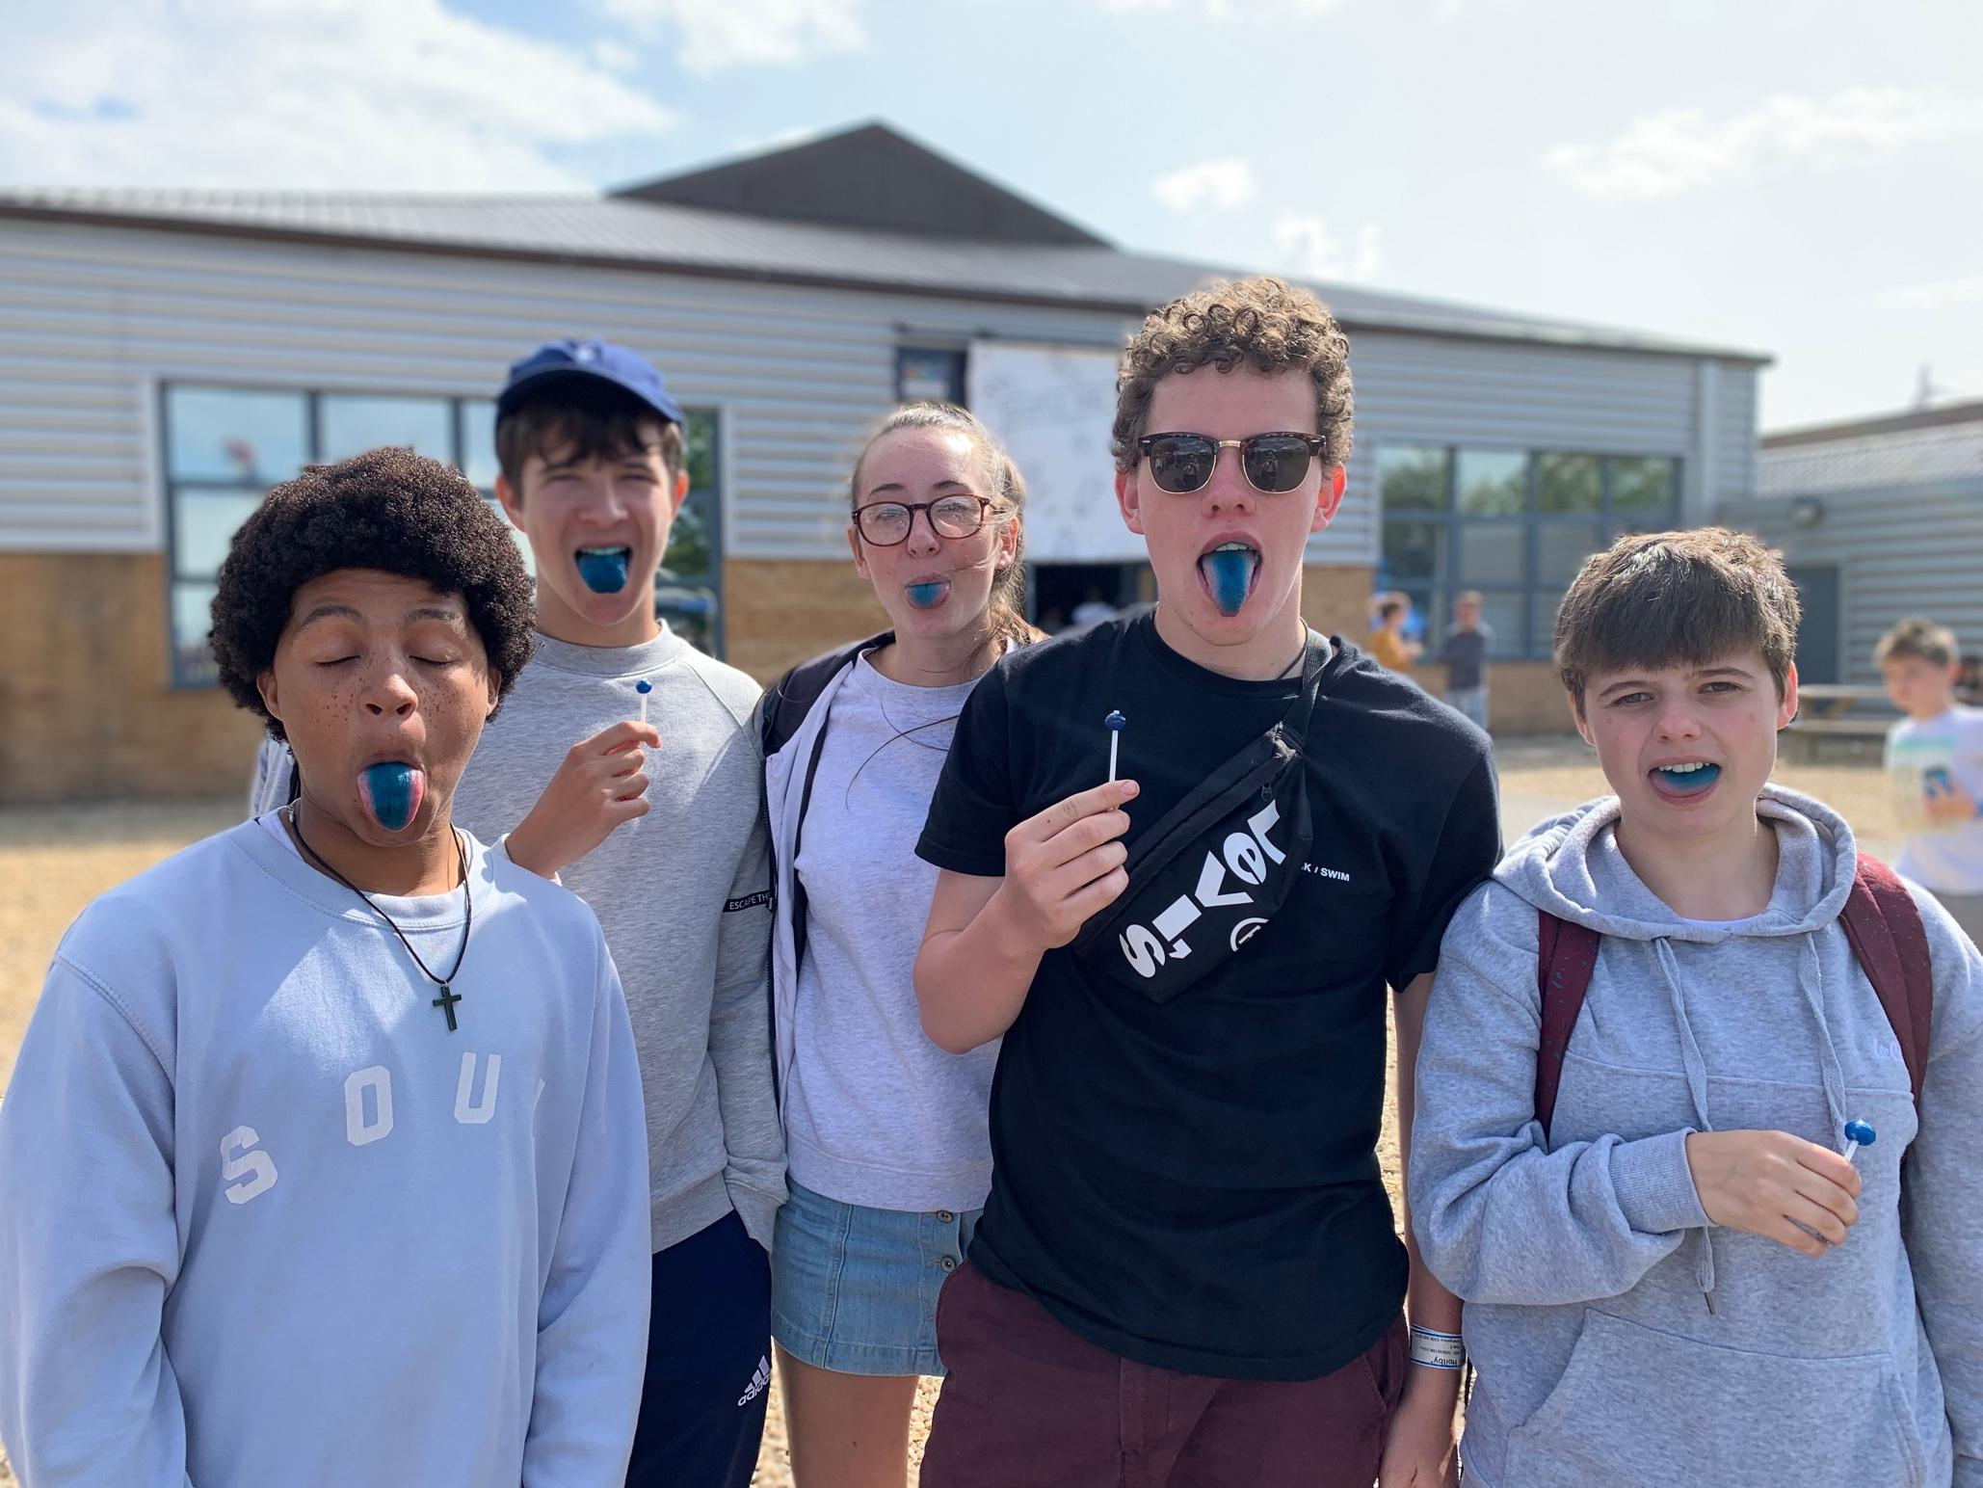

Youth & Student Pastor
Role Description

Building
the City in
the town

Introduction to St Paul’s

St Paul’s vision is to bring hope to the people of Weston-super-Mare. We aim to play our part in seeing the town renewed and lives restored, as we follow the way of Jesus.

We are a large growing church made up of people from a diverse community united around a vision for our town - to build the City of God here. In March I joined the team as Vicar, and together, we’re building something new for the people of Weston-super-Mare. It is an exciting time to join the team and our youth and student ministry remains very important in the life of the church family.

This role is part of a large Staff Team who will support and encourage you as you take this important ministry forward. You won’t be doing everything by yourself — as our culture is one of trust, teamwork, and encouragement.

We believe that a community of youth and students centred on Jesus - empowered by His Spirit - can achieve seemingly impossible things and we’re excited to work with you to achieve this. We value both Word and Spirit, relying deeply on the Scriptures and the work of the Holy Spirit today.

Weston-super-Mare is in a period of regeneration, with ambitious plans to build a thriving University town, so there’s much more that we can be doing to develop our youth and student ministries here. This is why St Paul’s is always adapting; always listening; always learning; and always growing.

So, if you fancy joining a large and lively team in a beautiful seaside town, growing our young people in their discipleship journeys and setting their hearts on fire for Jesus… then we’d love to hear from you.

Do get in touch for an informal chat or to arrange a visit — contact details are on the last page. To apply, submit your CV with a covering letter showing how you meet the personal specification of the role.

With our prayers,

Craig Philbrick
Vicar

St Paul’s Strategy

Our strategy is based on a saying attributed to Augustine of Hippo: We pray as if everything depends on God; and work as if everything depends on us.

Evangelism is the very centre of St Paul’s as we seek to introduce people to a life changing relationship with Jesus. Our mission is simply ‘Reach, Teach, Mend, Send.’ Within St Paul’s we have four marks of membership to help people engage with the community:

- Worship weekly
- Join a Branch (small group)
- Give financially
- Serve in a Team

Staff are to model this lifestyle and connect fully with the wider church membership.

We seek to offer a diverse range of opportunities for people to engage with the church community. This is characterised with different worship styles offered every Sunday:

- The 9.30 - a more structured service
- The 11 - family friendly informal worship with teaching and ministry. Includes Children and Youth provision
- The 7 - worship, teaching and ministry with a focus on students and young adults

Role Information
St Paul’s are looking to appoint a Youth and Student Pastor who has a strong, mature, personal Christian faith. We are looking for someone who is highly relational and passionate about serving and loving young people to enable them to grow in life and in faith. The role offers the flexibility to develop and alter the existing church vision and programme as opportunities arise and needs change, and to work flexible hours around these opportunities. The person appointed will be able to demonstrate leadership and have autonomy in managing their own workload, and will work some evenings, weekends and every Sunday. They will be supported by the Vicar, and be an advocate for Youth and Students to the Senior Leadership team and the wider church community.

Accountability and support
- Meet at least monthly with the Vicar for supervision, and annually for an appraisal
- Attend weekly staff meetings and report on ministry developments
- Communicate the work in the staff team, to the PCC and other appropriate settings
- Be linked with congregation members who commit to pray regularly for you
- Link with support provided by the Diocese

Responsibilities

Leadership and administration:
- Lead and develop the vision for the development of the Youth & Student Ministry in the church and wider community.
- Have oversight of the ministry amongst young people and students, bring a sense of consistency, cohesion and inclusion that is fully in line with the overall vision and aims of St Paul’s.
- Grow, support, resource and equip the team of volunteer leaders in planning and delivering this vital area of our ministry.
- Oversee the Youth and Student Ministry Team rotas, registers, and communications.
- In conjunction with the Safeguarding Lead, ensure that the Youth and Student Ministry is undertaken safely in full accordance with the Safeguarding Policies, Risk Assessments and GDPR, including keeping up-to-date contact details.
- Build and develop positive working relationships with the Diocese, youth workers in churches across Weston and the Locking Deanery and with other Christian organisations.

Youth / Student Ministry
- Build deep, intentional relationships with young people and students aged 11-21, providing a range of activities that will nurture faith and encourage lifelong discipleship.
- Develop creative and relevant ways to help young people and students outside of the church to explore faith and encounter Jesus, e.g. in local secondary schools, by running a Youth club etc.
- Enable young people and students to develop resilience and equip them to live out their faith
- Identify and nurture the gifts and skills in young people and students so they can serve and lead across all areas of ministry and church life at St Pauls.
- Work with the Children’s Team leaders, supporting the transition from Children’s Ministry to Youth to Student Ministry.
- Champion the voice of young people and students in helping to shape the ministry and vision of the church.

Schools / Student Ministry
- Look for opportunities to develop relationships with secular bodies in Weston e.g. Secondary Schools and Weston College.
- Support students as they transition into other aspects of Higher Education or work.

This list is not exhaustive but provides the outline of key responsibilities for the role

Personal Specification

Area | Essential | Desirable
Qualifications, Knowledge and Experience | - A professional qualification or proven experience in youth/student ministry, teaching or chaplaincy  - Able to demonstrate they can fully carry out the role  - Experience of leading, running and resourcing Christian youth/student ministry  - Knowledge and understanding of Safeguarding and other relevant policies  - A good knowledge and understanding of the Bible and how to use the Bible when teaching and leading sessions  - Able to support, care for, lead and equip teams of volunteers | - Some understanding of how the Anglican church works and its structures  - Experience of working with Secondary Schools, Further Education or Higher Education  - A good understanding of issues that young people/students face today
Skills, Competence and Ability | - Good organisational and time management skills  - Able to take their own initiative whilst working as part of a team  - Excellent written, verbal and communication skills, including using of a computer  - A good listener  - Commitment to the care and well-being of others | - Able to communicate the Christian faith in relevant and vibrant ways with young people/students inside and outside of the church  - Experience of and an ability to work with technology and social media
Work Related / Personal Qualities | - A personal, mature faith  - Have energy, enthusiasm and passion for ministry with young people/ students  - Someone with integrity, courage and durability  - Willing to work flexibly including some evenings and weekends  - Someone who is approachable and caring  - Commitment to make St Paul’s their home church base | - Open to working in partnership with others  - Able to build good relationships with others  - Someone with a sense of humour and fun about them.  - Holds a valid driving licence with primary use of a vehicle

Salary and conditions
This role is full time, 37.5hrs per week including Sundays.
We also welcome applicants who would like to undertake either the Youth or Student Pastor role on a part time basis.
Salary £23,000 to £26,500.
5 weeks holiday per annum.
6 month probationary period.
There is a Genuine Occupational Requirement (GOR) that the holder of this post is a practising Christian. This post will also require two references and be subject to an enhanced Disclosure & Barring Service check.
Closing date 18th August 2022 and interviews date 6th September 2022
For more information or to have an informal conversation please contact Craig Philbrick on 07539 408004.

To apply, submit a completed application showing how you meet the personal specification of the role, to Dorcas.Moore@stpauls-weston.org.uk

www.stpauls-weston.org.uk

St Paul’s Church, Walliscote Road, Weston-super-Mare, North Somerset. BS23 1EF
St Paul’s PCC is a registered charity number 1132828

