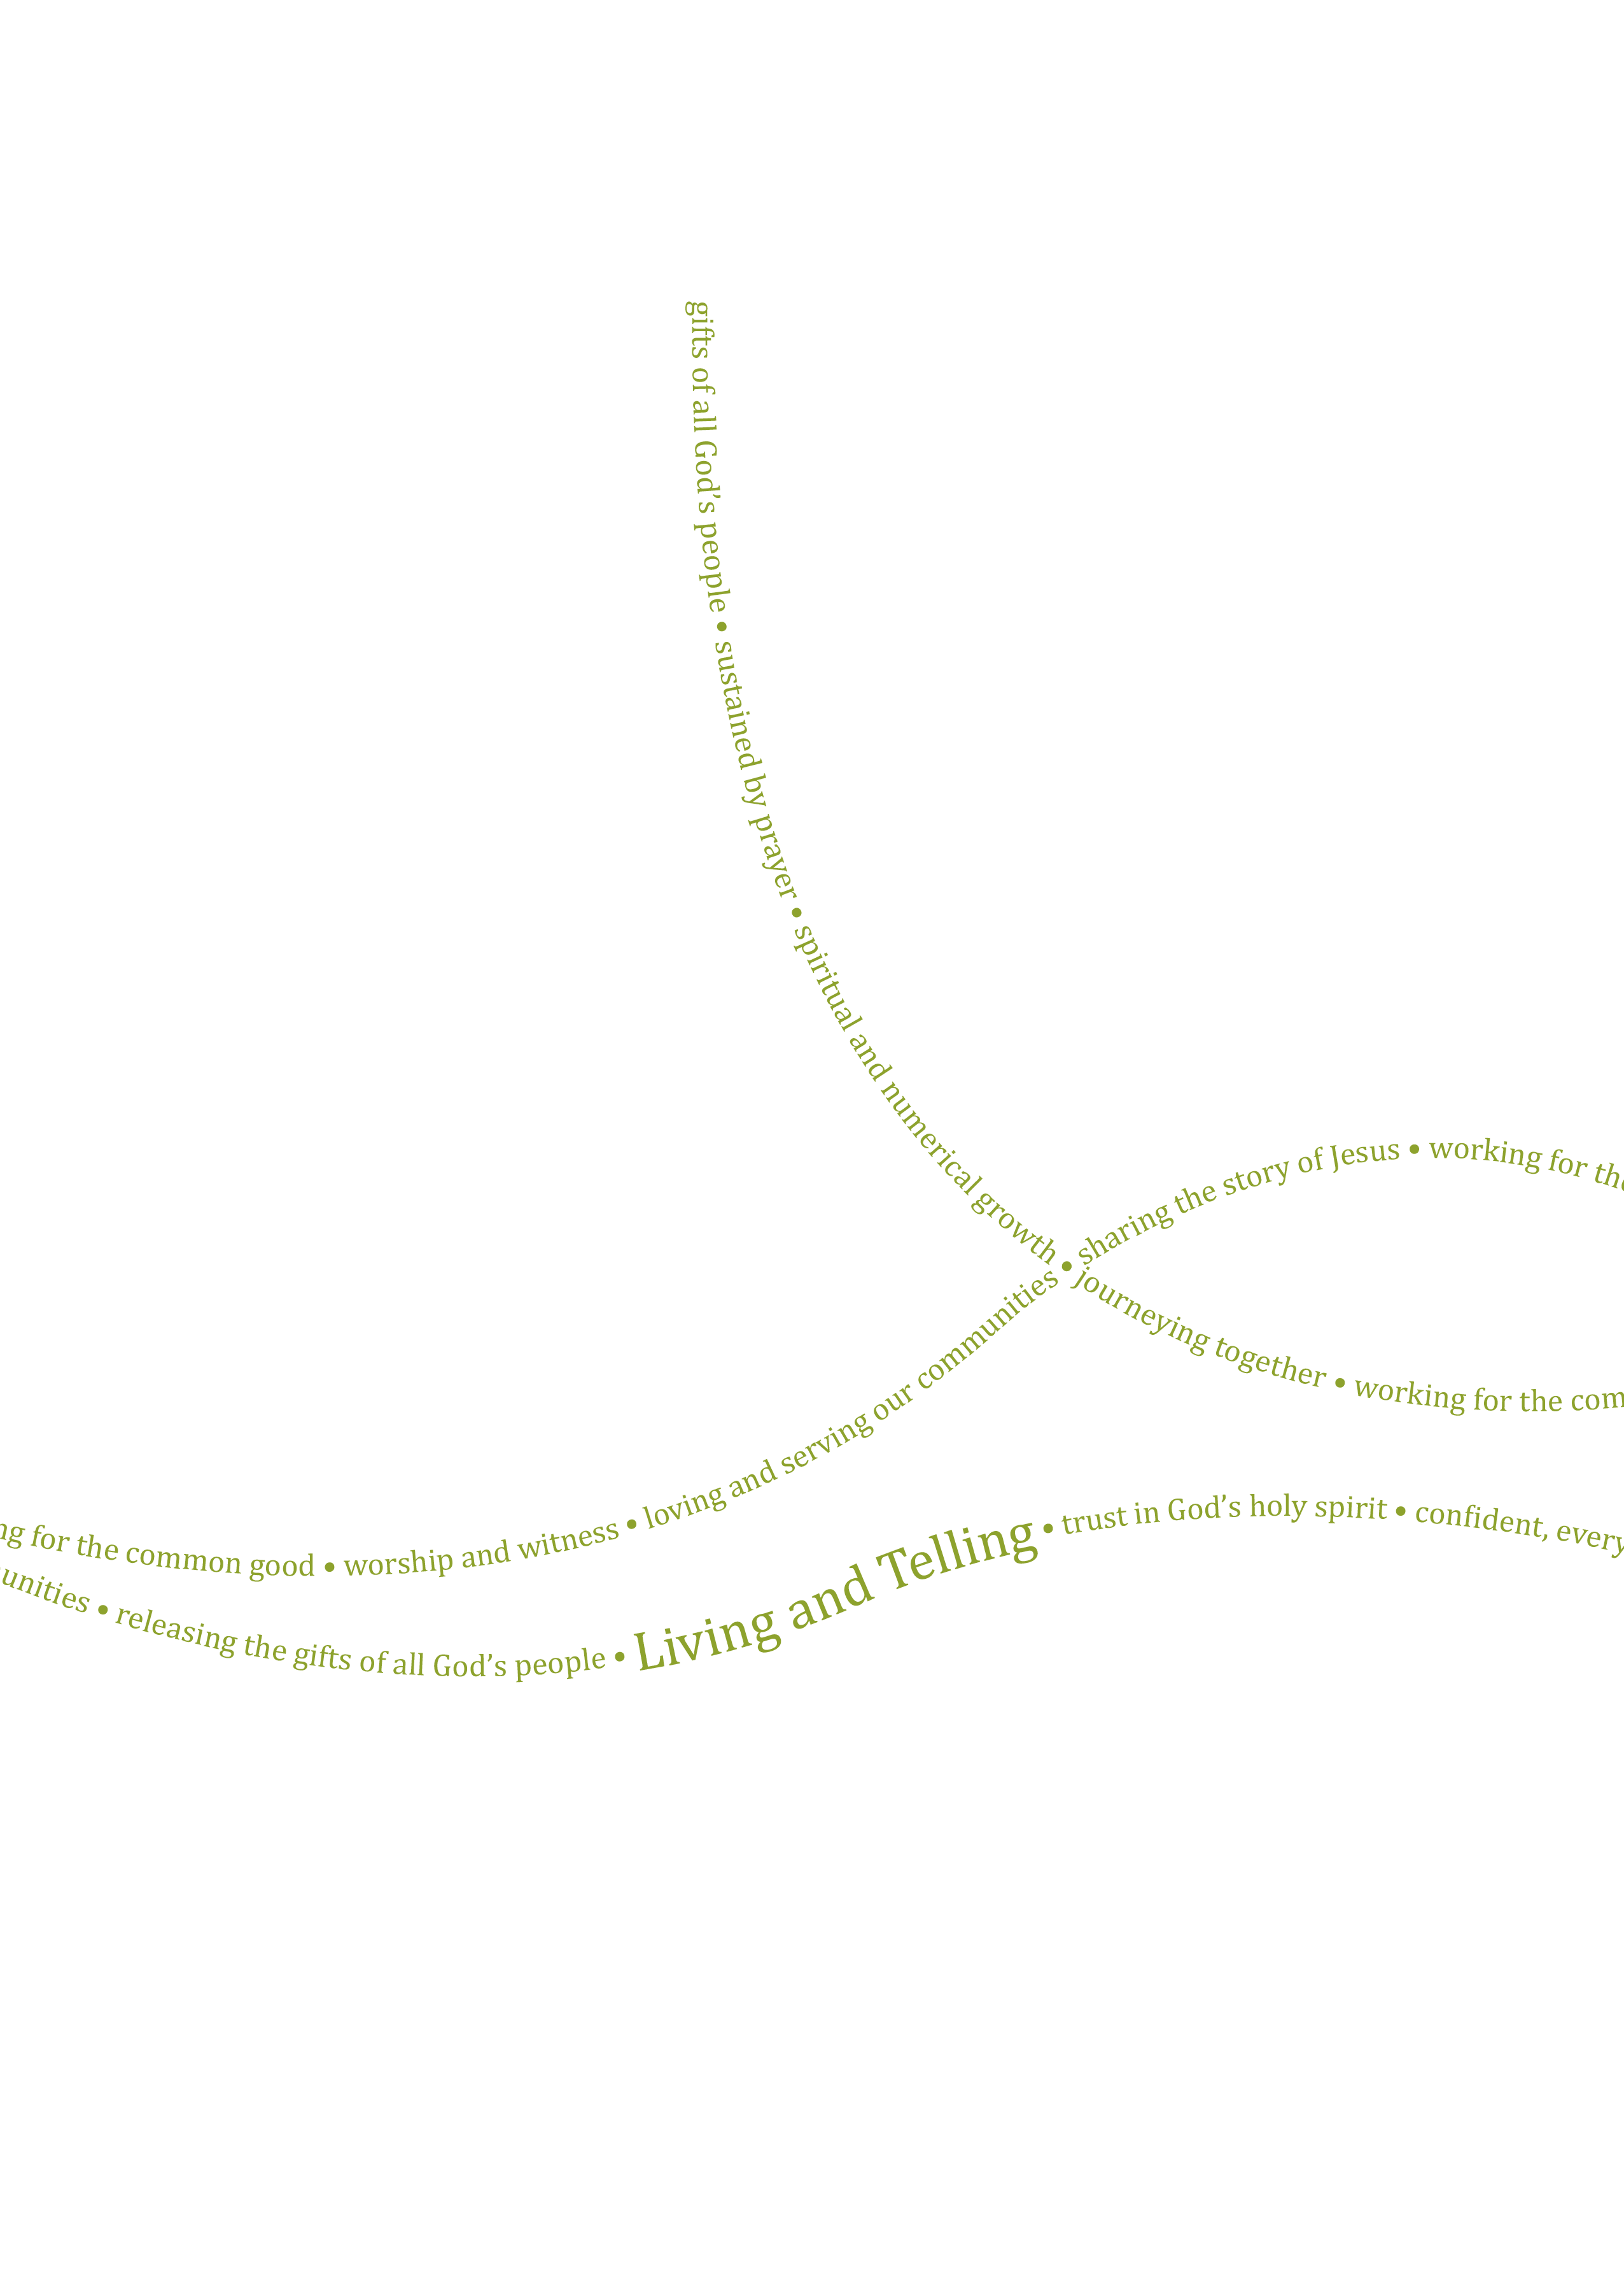
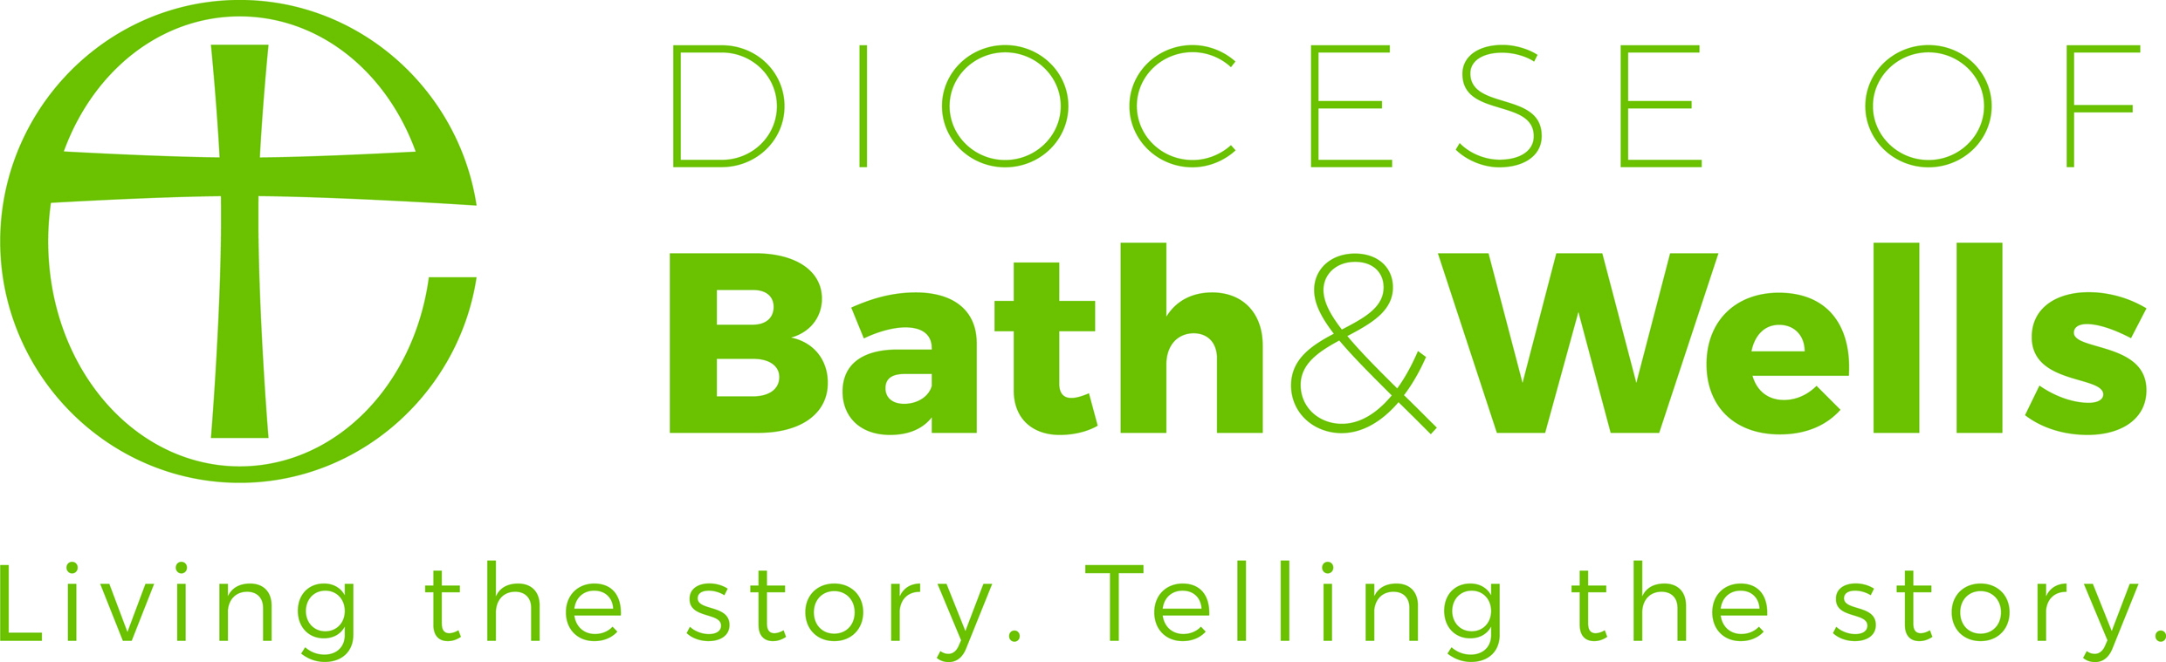

Zambia Link Coordinator (Fixed Term)

Application Pack March 2023
Contents

Recruitment Timeline
The Diocese of Bath and Wells
About the Role
Job Description
Person Specification
Main Terms and Conditions

Contact details

Human Resources
Enita Andrews
Ph: 01749 685 113
Email: recruitment@bathwells.anglican.org

For an informal discussion about the role, please contact:
Mike Haslam
Chaplaincy Adviser & Acting Mission Development Team Leader
Ph: 07530 677493
Email: mike.haslam@bathwells.anglican.org

Dear applicant

Thank you for your interest in the post of Zambia Link Coordinator with the Bath & Wells Diocesan Board of Finance (DBF). I am delighted to let you have details about the diocese and information about the post.

We hope you find the application pack provides all the information you need in order to consider your candidature for this post. If, however, you have any further questions please initially contact Human Resources.

Meanwhile, please find opposite, key dates for the appointment process. Should you decide to apply for this post we look forward to receiving your application and wish you well.

Kind Regards

Enita Andrews
HR Manager

Applications
Applications must be received by 9am Monday 17 April 2023. Application forms, with a covering letter no more than one side of A4 describing what attracts you to this role should be returned to Human Resources either by post to The Diocesan Office, Flourish House, Wells, BA5 1FD or by email to recruitment@bathwells.anglican.org.

Shortlisting

Shortlisting will take place on Thursday 20 April 2023. To ensure the fairness of the selection process, shortlisting will be based upon the information which you provide in your application and assumptions will not be made about your experience or skills. We will look for demonstrable evidence that you meet the criteria set out in the person specification. If after 3 weeks from the closing date you have not heard from us, please assume that you have not been shortlisted on this occasion. A copy of our privacy policy for job applicants can be downloaded from our website.

Interview

Interviews will take place in Wells on 2 May 2023. Further details regarding the selection process will be communicated at the time applicants are invited for interview.

Safeguarding

We are committed to the safeguarding and protection of all children, young people and adults, and the care and nurture of children within our church communities. We will carefully select, train and support all those with any responsibility within the Church, in line with Safer Recruitment principles. This means that we will:
- Ensure that our recruitment and selection processes are inclusive, fair, consistent and transparent.
- Take all reasonable steps to prevent those who might harm children or adults from taking up, in our churches, positions of respect, responsibility or authority where they are trusted by others.
- Adhere to safer recruitment legislation, guidance and standards.

Further information can be found in our Safeguarding Policy available on the diocesan website. All applicants are required to complete a Confidential Declaration Form as part of our recruitment process when an offer of employment is made. This form is strictly confidential and, except under compulsion of law, will be seen only by those involved in the recruitment/appointment process and, when appropriate, the nominated safeguarding lead or someone acting in a similar role/position. All forms will be kept securely in compliance with the General Data Protection Regulation, 2018.

The Diocese of Bath and Wells

The Diocese of Bath and Wells is one of 41 Church of England dioceses in the country. The diocese stretches from Portishead in the north to Crewkerne in the south, Minehead in the west to Frome in the east.

The diocese loves and serves the 940,000 people who live here through its family of 466 parishes and 181 church schools. This family works for the good of local communities in a range of practical as well as pastoral ways: caring for the vulnerable in our societies, supporting local families and encouraging children and young people.

Everything the diocese does is underpinned by prayer and worship and is driven by our vision:

“In response to God’s immense love for us, we seek to be God’s people, living and telling the story of Jesus.”

If successful in your application, you will be arriving in the diocese at a time of significant change and you will have a role to play in the diocesan strategy, which has these three strategic priorities:

- To place mission and evangelism at the heart of all we do.
- To re-align our ministry resources towards mission.
- To identify, develop, and release the gifts of all our people.

About the Role

This role was created primarily to support and develop the Diocese of Bath & Wells companion link with the Anglican Dioceses of Zambia. From time to time there may be limited capacity to participate in broader events and activities within the scope of the World Mission and Global Justice Governance Group or the Mission Development Team.

The Link relationship between Bath and Wells and the Dioceses of Zambia is at the heart of this post. We seek to affirm and continue relationships that have developed over 45 years, particularly with sustainability in mind. Through the Link the diocese and its parishes exercise, by example, their common mission with the Worldwide Anglican Church and encourage congregations to think beyond their parish boundaries and share in the richness and diversity of a global faith.

The link between Bath and Wells and the five Anglican Dioceses of Zambia was established in the late 1970s, and the 40th anniversary of the companion link was celebrated in Zambia and Bath and Wells in 2018. Through this link, there have been exchange visits, the creation of parish and more recently school links, and significant personal contacts which have been strengthened by prayer and evolving fellowship. There has also been a significant, sometimes sacrificial, giving of monetary gifts by parishes and individuals to Zambian parishes and programmes. Growth of individual parish and school links and renewal of long-standing partnerships are central aims of the diocese.
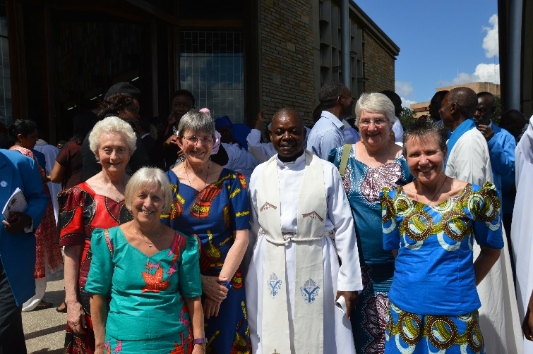
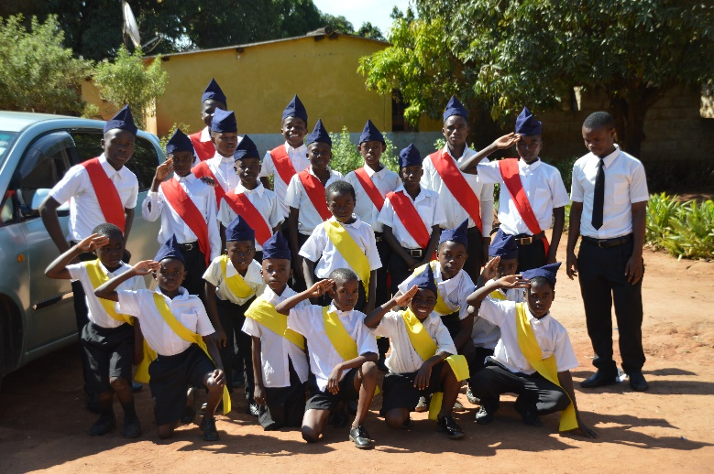

Boy’s Brigade Band, Ndola North Parish

Visitors from Bath & Wells at Cathedral of the Holy Cross, Lusaka, 40th Anniversary celebrations April 2018

Job Description

Post: | Zambia Link Coordinator (Fixed Term)

Our vision: | In response to God’s immense love for us, we seek to be God’s people, living and telling the story of Jesus.

Key purpose of the role: | To support and develop the links between Bath and Wells and Zambia.

Location: | Diocesan Office, Wells

Reporting to: | Mission Development Team Leader (Line Manager) and accountable to World Mission & Global Justice Governance Group.

Hours of work: | 10 hours per week (flexible, but to include one regular day)  Fixed term for 3 years due to funding, contract will be reviewed at end of 3 years with a possibility of renewal of contract.

Renumeration: | £25,000 per annum, pro rata. Actual salary £6,945 per annum.

Key relationships: | - World Mission & Global Justice Governance Group (WM&GJGG)  - Mission Development Team and wider support services staff  - Bishops and senior church leaders in Zambia and Bath and Wells  - Local church and school Leaders in Zambia and Bath and Wells

Background:

The role was first established in 2018 to co-ordinate celebrations of the 40th anniversary of the Link. The Link itself is an expression of mutual companionship and encouragement as we travel together to bring God’s kingdom to our respective contexts. Through relationships of understanding and experience, our life in Bath & Wells is enriched by understanding of each other’s challenges and joys. Having a coordinator as a focal point has been hugely beneficial for our parish and school links and for maintaining communications and the Zambia link profile. A similar post is being considered in Zambia. The post holder will work with and be accountable to the WM&GJGG.

Funding will continue to be provided from the Coppen Legacy (under Bath & Wells Diocesan Board of Finance). The post will be reviewed every year after the initial fixed period.

More information can be found on our website:
www.bathandwells.org.uk/faith/world-mission-and-zambia-partnership/zambia-partnership/zambia-partnership.php

Main tasks and responsibilities

- Establish and maintain regular contact with Zambia Link parishes and schools in Bath and Wells and maintain a record of that contact using the spreadsheet established for that purpose.

- Encourage new parish and school links to form and support new advocates for the Zambia link to build sustainability.

- In coordination with the Mission Development Team Leader, communicate with Zambian Anglican Council or Zambian Diocesan staff, as appropriate, to address any challenges or misunderstandings and alert the Chair of WM&GJGG to any issues of policy or procedure that require more senior intervention.

- Produce a Zambia link newsletter 2 or 3 times a year and update the Bath and Wells website with information on the link as required.

- Support and encourage engagement with Bath and Wells/Zambia Sunday.

- Support the WM&GJGG in its remit to oversee financial and strategic matters.

- Administer the travel bursaries programme and provide support to scheme travellers.

- Support Mission Development Team Coordinator on any funds transfer questions.

Person Specification

Area | Essential | Desirable
Qualifications Knowledge and Experience | - Understanding of the Christian faith and how this relates to world mission.  - Experience in world mission.  - Experience of local churches and their structures  - Knowledge and understanding of safeguarding. | - Experience in working with schools.
Skills, Competencies and Abilities | - Able to take their own initiative and also work as part of a team within Mission Development and the WM&GJGG and with local and Zambian churches and schools.  - Experience of working with churches and communities from sub-Saharan Africa or other parts of the Anglican Communion and an ability to develop and maintain good relationships across the diocese and with Zambian contacts. | - Experience of and an ability to work with technology and social media.  - Administrative skills and experience of producing newsletters, organising events and booking travel.
Work Related Personal Qualities | - Commitment to learn and experience new things, and to live and share faith along the way.  - An ability to relate and quickly build trust with link parishes and schools and a willingness to work in partnership with others.
There is a Genuine Occupational Requirement that the holder of this post is a practising Christian and a member of a church.

Main Terms and Conditions

Hours of Work | 10 hours per week (flexible, but to include one regular day)  Fixed term for 3 years due to funding, contract will be reviewed at end of 3 years with a possibility of renewal of contract.  Core office hours are 9am until 5.15pm Monday to Thursday and from 9am to 5pm on Fridays with an hour unpaid lunch break taken as appropriate. Some (but not frequent) evening and weekend work may be required. Hybrid and flexible working will be considered.
Salary | £25,000 per annum, pro rata. Actual salary £6945 per annum.
Pension | Pension Scheme administered by the Church of England Pensions Board. The employer will contribute 10% of the employee’s pensionable salary and the employee may choose to make an additional voluntary contribution of any proportion of their pensionable salary.
Holiday | 25 days per calendar year plus bank holidays (pro-rata for part-time staff)  The holiday year runs from 1 January to 31 December.  Additional discretionary days are given at Christmas and Easter.
Expenses | All reasonable working expenses will be met at the agreed Diocesan rates.
Probation | This post will be subject to a probationary period.
